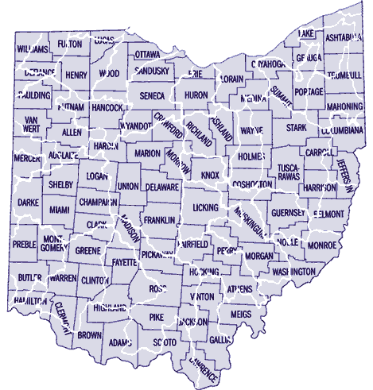

Comments:
- The white lines outline Ohio’s unnamed watersheds.
- The black lines outline Ohio’s named political county boundaries.
- Nature’s watersheds may also define Northeast Ohio (NEO).
- A “Continental Divide” separates the northern part from the southern part of NEO.
- Political boundaries are arbitrary and can be changed.
- Natural watershed boundaries cannot be changed easily.
- Principle: We should define the NEO region using natural watershed boundaries.
- Where do you think the NEO region extends, if only natural boundaries are used?
- Where do you think the NEO region extends, if only political boundaries are used?
- Did you include any part of Lake Erie in your extents?

