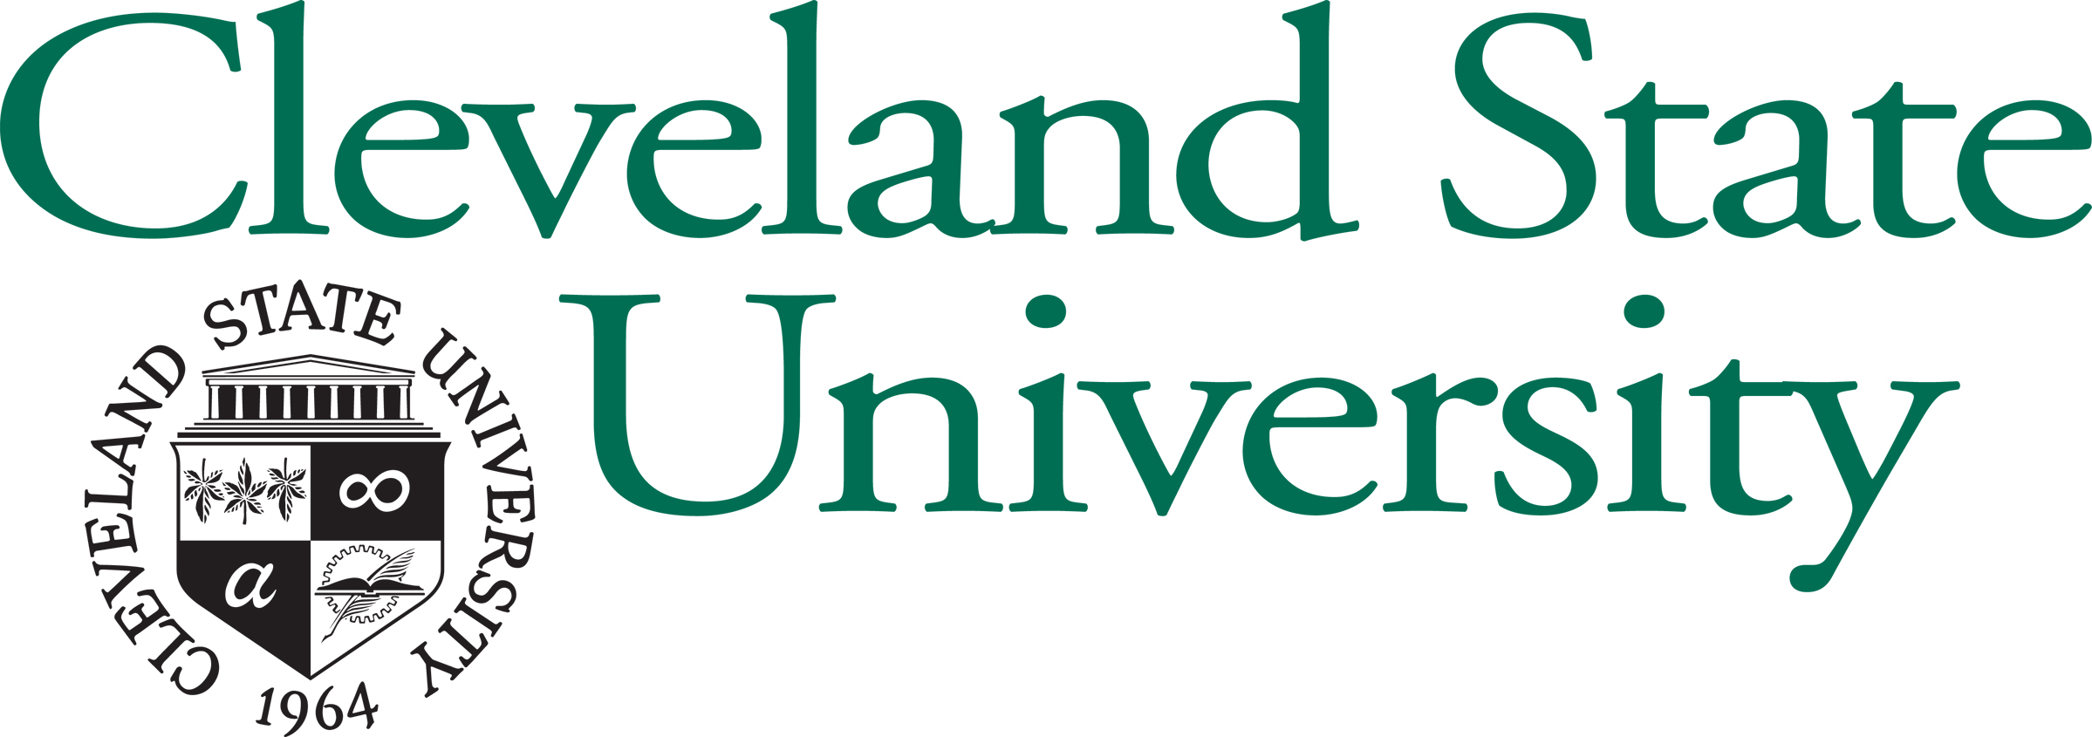

April 7, 2005

«Prefix» «First_Name» «Last_Name»
«Position»
«Company»
«Address_1»
«Address_2»
«City_State_Zip»

Dear «First_Name»:

On behalf of the Levin College of Urban Affairs and students in the Urban Planning Capstone Class at Cleveland State University, thank you for the time and expertise you shared with our students regarding regional government issues in Northeast Ohio. Your candidness and experience continue to play a role in their analysis of opportunities for regionalism in a seven-county Northeast Ohio area.

We also wish to invite you to attend the students’ final presentations. As the final component of their masters degrees in Urban Planning, Design, and Development, the class will be putting together the research and analysis they have been conducting over the past three months into a public presentation called “Got Regionalism?”. The students will be addressing five different possibilities of regionalizing or consolidating services and governing entities. The scenarios range from doing nothing different, to tweaking service consolidation, merging services, merging governments, and a Uni-Gov scenario. These scenarios will each assess issues of government budget efficiency, equity, planning and the quality of life. We hope that this event may serve as a springboard for a new type of public discussion about the future of Northeastern Ohio.

“Got Regionalism?” will be held in the Atrium of the Levin College of Urban Affairs, located at 1717 Euclid Avenue, on Thursday, May 12, 2005, from 4:00-6:00 pm. We hope you are available to attend. Please visit www.clevelandregionalism.com to learn more about the event and to register.

We hope you will find the students’ presentations to be as informative and engaging as they found yours to be. We look forward to seeing you at the event.

Sincerely,

Dr. Robert Simons Professor Jim Kastelic

