Nicole Keels
PDD 611 CAPSTONE
ANALYSIS – PUBLIC UNIVERSITIES

There are eight public post secondary institutions in the seven county area of Cuyahoga, Geauga, Lake, Lorain, Medina, Portage, and Summit:
- Cleveland State University (Cuyahoga)
- Cuyahoga Community College (Cuyahoga)
- Kent State University-Geauga (Geauga)
- Lakeland Community College (Lake)
- Lorain County Community College (Lorain)
- Kent State University-Main Campus (Portage)
- Northeastern Ohio Universities College of Medicine/NEOCUM (Portage), and
- University of Akron-Main Campus (Summit).

NUMBER OF INSTITUTIONS

There are 13 public four-year campuses in Ohio and two freestanding medical colleges. There are also 58 independent colleges in Ohio. There are 24 community and technical colleges, 23 university branch campuses and five independent two-year campuses in Ohio. Five of 4-year universities reside in the area being studied. Three of 2 year colleges are within this area. Cuyahoga County has 2 public institutions (one four-year university and one two year college). Geauga County has 1 public institution (one 2-year), Lake County has 1 two year college; Lorain has one 2-year college, Medina has none; Portage has two 4-year institutions, and Summit has one 4-year institution. According to the Ohio Board of Regents, Ohio has fewer institutions of higher education than the national average.

REVENUES AND EXPENSES
The average revenues per student FTE generated from tuition and fees in the 7 county area is $18,736. Northeastern Ohio Universities College of Medicine’s in Summit County average fees per student fte are almost five times the amount of other institutions. If this school is taken out of the average, a more representative average revenue per student fte is obtained of $10,005. Cuyahoga County’s total is almost $28,000, where Summit is second at approximately $9735. Lake County comes in third at 9,421 and the remaining counties come in behind with Lake and Geauga. There are no post secondary public institutions in Medina. Portage would be considered to generate the most revenues at 95,128 due to the NEOUCM. There was no data for Summit County at the time of this analysis. The core revenues include revenues from fees and tuition, government appropriations and grants and contracts, grants, private gifts, and investment or endowment income or returns.

The total expenses per student FTE is $18,619 for the North Eastern Ohio Region. The adjusted expenses (not including NEOCUM) is $8,283 per student FTE for the region. After NEOCUM, Cuyahoga County ranks second with $25,987 and Lorain ranks third with $9,898 in total expenses per student fte. In general, cores expenses exclude expenses for auxiliary enterprises (e.g., bookstores, dormitories), independent operations and hospitals.

TUITION

The National Center for Public Policy released a report on September 15, 2004, which ranked state college’s affordability. The center rates use three criteria: families' ability to pay, strategies for affordability and reliance on loans. Ohio was given an F." Tuition in Ohio is higher than the national average due to a lack of state support for higher education. On average, statewide undergraduate in-state annualized tuition and fees at state-supported four-year universities in 2003-2004 was $6,822. At two-year public colleges, statewide undergraduate tuition and fees in 2003-2004 were $2,966.

FUNDING

Ohio has 47,403 more full-time college and university students than four years ago while funding has remained flat, according to the Board of Regents, the state's coordinating body for higher education.

Local
Six campuses (community colleges) receive local levy support in Ohio. Half of the campus are within NE Ohio and include
- Cuyahoga Community College,
- Lakeland Community College, and
- Lorain County Community College.

State
Ohio’s FY 2003-2004 General Budget was 20.6 billion. 11.9% went towards higher education in comparison to the previous year of 12.3%. There has been a trend of decreasing funding from the state as is illustrated in Figure 1. below

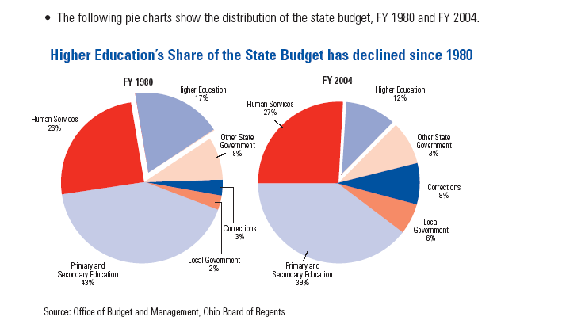
Figure 1 Higher Education Funding Decreasing

FY budget is Governor Taft’s proposed budget for the upcoming year would mean that nine of Ohio's 13 public universities, including Cleveland State, would see a drop in state support over the next year. 11 out of the 15 community colleges would see increases under this funding formula that rewards enrollment growth. Taft's budget would send higher education almost $1.56 billion in each of the next two budget years (which is the same amount it will receive this year). His proposal shifts more of the money to community colleges, which are experiencing increased enrollment. Cuyahoga Community College, which has 26 percent more students than it did four years ago, would receive approximately an 8 percent increase in fiscal year 2006 and 3 percent more the following year. Lorain County Community College would get a 3.7 percent increase in the first year of the budget and 3.6 percent the second year. There are many in the academic community who are not fond of the formula. According to University of Akron President Luis M. Proenza, " No matter if the university is growing, if anyone is growing faster than you are, then you lose money." According to the director for Equity and Adequacy of School Funding, when you take into consideration inflationary costs, schools will be less well off than they are now and property tax issues will increase.

Higher education would see total increases in state funding of 0.4 percent in 2006 and 1.9 percent in 2007, but the state subsidy that goes directly to colleges and universities for instructional costs would be frozen at current levels. He believes that with the current funding (or lack thereof), there will inevitably be increases in tuition across the state.

Federal

The National Science Foundation reports that Ohio is lagging the national average and the region in federal academic Research and Development (R&D) performance.
If Ohio were at the national per capita average for R&D performance, each year an additional $299 million would be invested in Ohio and an additional 10,600 Ohioans would be employed in jobs directly related to research. The national average is approximately $105, and Ohio is at $80 per person. NSF asserts that Ohio needs to do more to secure its share of federal dollars, as these federal programs are highly competitive.

GRADUATION & TRANSFERS

Portage County boasted an average graduation rate was almost 50%, with Summit trailing very closely behind at 47%. Cuyahoga’s was nearly half of Portage’s. Graduation rates are defined as the total number of individuals from a given cohort of first-time, full-time, degree/certificate-seeking undergraduates who complete a degree or certificate within 150% of normal time for completion of their degree or certificate, divided by their entire cohort of first-time, full-time, degree/certificate-seeking undergraduates minus any allowable exclusions. Allowable exclusions include students who died or were totally and permanently disabled; those who left school to serve in the armed forces; those who left to serve with a foreign aid service of the federal government, such as the Peace Corp, and those who left to serve on an official church mission. Cuyahoga lead the pack in transfer rate of 34% and Summit County was at the bottom with a mere 2%. On average, about one-fourth of Portage’s students transferred to higher institutions of learning.

ENROLLMENT

The largest enrollment students is seen in Cuyahoga County with over a little over 17,000 fulltime and about 22,000 part time students. Almost 19,000 students enrolled on a full-time basis in Portage County and 6,000 part-time. There are more part-time than full-time enrollees in Cuyahoga, Geauga, Lake, and Lorain. For the other southern counties of Summit and Portage counties, the opposite is true.

According to a report published by the Ohio Regents, Ohio is disappointedly an under-educated state, with a baccalaureate attainment rate of 21.9% in comparison to the national average of 84.6%.

CURRENT COLLABORATION

Sharing Services

The Northeast Ohio Council on Higher Education is the representative body and service organization for the 23 universities and colleges in a 13-county region. Seven of these member facilities lie within the geographic area being analyzed. This consortium is very powerful in their impact on the region as seen in the table below.
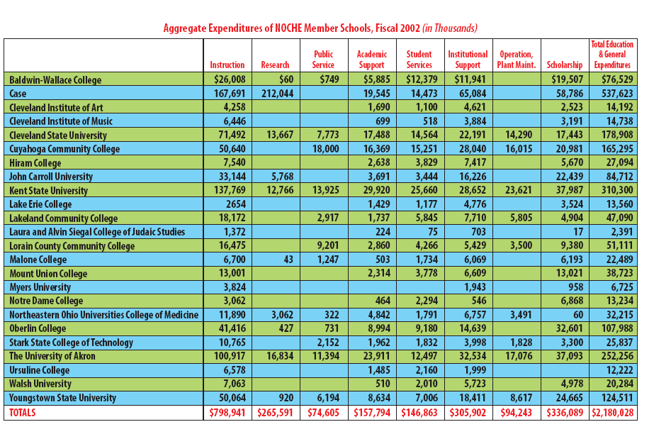The Northeast Ohio Council on Higher Education (NOCHE) was one of the first organizations historically devoted to Cuyahoga County to recognize the necessity of expanding its vision and operations to the larger region. Today, NOCHE activity includes the counties of Ashtabula, Columbiana, Cuyahoga, Geauga, Lake, Lorain, Mahoning, Medina, Portage, Stark, Summit, Trumbull and Wayne. Cross-registration is one of the many programs coordinated through the Northeast Ohio Council on Higher Education Cross-registration turns member campuses of Northeast Ohio into one large one if you are a full-time student at one of the member schools. The other objectives of NEOCHE include linking member institutions’ expertise with key area employers to build workforce capacity and strengthen regional economic development; assisting in the efforts by member schools to increase rates of research funding and technology transfer; providing professional development services to member institutions; collect, analyze and publish data on regional trends in higher education; and facilitate efficiencies and effectiveness in selected forms of community outreach by member institutions.

The following information was taken directly from A Policymaker’s Guide to Public Education: 2004 published by the Ohio Board of Regents. All of the information is extremely important to the concept of regionalism and because this data will be used in to draw conclusions about the colleges in Northeastern Ohio, I thought it prudent to leave the bulk of it intact.

Statewide Shared Purchasing Consortium
The Inter-University Council (IUC) is A voluntary educational association of Ohio's public universities since 1939. It is comprised of all thirteen four-year universities and two medical colleges in the state. For decades, it has managed several successful cooperative purchasing programs that reduce costs at state-supported universities and colleges.
Two-year campuses have similar cost-saving arrangements. These joint purchasing activities include:
- Group purchasing agreements to take advantage of high-volume purchases
- Pooled joint risk pool for lower-cost property and casualty insurance
- A large volume statewide enterprise agreement with Microsoft
- Joint prescription drug purchasing arrangements
- These programs help Ohio’s campuses save millions of dollars per year.

Ohio Link
OhioLINK is the state’s electronic library system that makes statewide sharing of all college and university library resources possible. This minimizes the duplication of purchases and also takes advantage of economies of scale in the purchase of resource databases.
The state’s five Regional Library Depositories enable public campuses to store Infrequently used documents in low-cost, high-density, environmentally sound facilities, freeing up more expensive library space on campus for instructional or other use. The construction of these depositories has helped the state avoid having to build expensive new libraries, all the while ensuring that important documents are stored in a safe manner and are easily retrievable.

Most recently, many campuses are investigating the merits of collaborative arrangements in Information Technology and more generally, in administrative computing.

Efficiency-Oriented Distribution Formulas

- It’s not well-known that the primary state operating and capital formulas are designed to reward efficiency and hold down costs. For example, allocations of the state operating formula (called the State Share of Instruction) are based on statewide average costs. The use of statewide average costs rewards efficiency: campuses with lower-than-average costs benefit and those with higherthan- average costs do not.
- In the capital formula, campuses earn capital resources through a formula based on enrollments and the age of their facilities. By establishing a ‘price’ for state capital appropriations and a reward for moderate requests, the formula discourages campuses from over-investing in capital resources.

- Other changes in state subsidy policy give campuses an incentive in renovating and rehabilitating existing facilities instead of building new buildings.

- Higher education is committed to quality and efficiency. The vignettes provided above provide just a glimpse on the depth and breadth of this commitment, which has helped save hundreds of millions of dollars in the recent past.

RECOMMENDATIONS

There is extensive collaboration already taking place between the public colleges and universities in the 7 county area. I would encourage maintaining relationship and developing it either further. According to my research, this is already being explored by several organizations (i.e. NOCHE). The chief obstacle I see is that decreasing funding may put a halt to some of the very promising collaborative efforts being proposes and with the possibility of diminishing such efforts, the area stands to lose even more money because they won’t receive as much federal funding. The state’s funding is inadequate, and locally there is not much support for additional levies. With no funding, inevitably there will be an increase in tuition. The increase would make Northeast Ohio even less attractive for a prospective student as it already is not competitive with tuition rates. Unfortunately, it appears that the universities are really at the mercy of legislatures that somehow don’t understand the interrelatedness of higher education and economic growth and if this school of thought does not shift, Northeast Ohio will suffer even greater- not only in access to higher education, but economic expansion.

http://www.newsrecord.org/news/2004/09/30/News/Ohio-Flunks.At.University.Funding-736435.shtml
http://64.233.187.104/search?q=cache:hT9bkN6a6_IJ:www.iuc-ohio.org/docs/PDFeb12.pdf+northeastern+ohio+schools+budget+cuts&hl=en
http://toledoblade.com/apps/pbcs.dll/article?AID=/20050211/NEWS24/502110419
http://www.regents.state.oh.us/kea/Policymakers9-18.pdf
http://www.regents.state.oh.us/financial/Survey2002.pdf
http://www.regents.state.oh.us/financial/Survey2002.pdf

