Analysis on Northeastern Ohio Hospitals
By Nicole Keels
PDD 611 – Capstone

Hospital Overview

The seven county area of Cuyahoga, Summit, Portage, Geauga, Lake, Lorain, Medina, Portage, and Summit have a total of 43 hospitals and 15 healthcare systems. Almost 50% of the hospitals are within Cuyahoga County, with Summit at 19%, and Lorain, Medina, Geauga, and Portage following behind. The seven-county area hospitals expend over $10 billion dollars per year in services provided to the public. By examining each county, it can seen that the average cost of services is rather equitable across the region averaging approximately $1500, with Medina being the highest at $2700 in Medina. Special caution should be used with these averages because they both high-ticket items such as deliveries, specialized diagnostic tests to routine annual blood work. Some hospitals do more of one and less of the other and vice versa, but these services could not be broken out of the aggregate because the individualized data from each hospital was not accessible. There are a total of 15 health system spread across the region: Cleveland Clinic Health System, University Hospitals Health System, MetroHealth Medical System, Ardent Health Services, Lake Hospital System, Community Health Partners Regional Health System, EMH Regional Healthcare System, Akron General Health System, Summa Health System, Akron General Health System, Triad Hospitals, Inc., and lastly Select Medical Corporation. It should be noted that there were only 7 hospitals that did not belong to a hospital system:
- Children’s Hospital Medical Center of Akron (was unable to confirm whether it belonged to Akron General Health System),
- Robinson Memorial Hospital (Portage),
- Medina General Hospital (Medina),
- Wadsworth-Rittman Hospital (Medina),
- Hospital for Orthopedic and Specialty Services (Summit),
- Parma Community Hospital (Cuyahoga),
- and Kindred Hospital (Cuyahoga).

There does not seem to be a concentration of non-system related hospitals in any one particular county so further analysis would not appear to provide any insight. It is interesting to note that comparing the expenses and services to the non-system hospitals and the system hospitals, there does not appear to be a large difference in the average expense per service. Again, I must caution that different specialty services and the frequency of how often these services are rendered greatly influence this “average”.

Health Systems
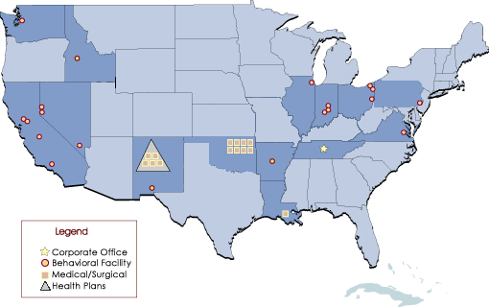
One of the most interesting facts is that 80% of the hospitals belong to a larger parent organization or health system. There are three systems, which only have one hospital in this area, but the point is that it appears that even though their geographic market is the U.S. in comparison to just that of Northeast Ohio, they still demonstrate the existence of a regionalized system:
- Ardent Health Services which specializes in a full range of medical/surgical, psychiatric and substance abuse services to patients ranging from children to adults,
Figure 1 Ardent Facilities
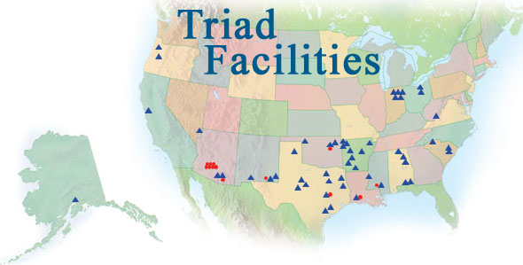
Figure 2 Triad Facilities
- Triad Hospitals, Inc. which operates facilities in two distinct markets primarily in the southern, Midwestern and western United States. Approximately three-quarters of Triad’s owned hospitals are located in small cities, generally with populations less than 150,000 residents and located more than 60 miles from a major urban center. These hospitals are usually either the only hospital or one of two or three hospitals in the community, and lastly
- Select Medical operates 99 long-term acute care hospitals in 26 states, and four acute medical rehabilitation hospitals in New Jersey. Select is also a leading operator of outpatient rehabilitation clinics, operating 741 rehabilitation clinics in the U.S. and Canada.

After speaking with several top officers and administrators at a couple of the largest health systems in the area, there appears to be a consensus that a merger of the University Hospitals Health Systems and Cleveland Clinic Health Systems will not happen “in this lifetime” due to politics and neither have a fiscal need to merge as and both are doing very well financially. It was emphasized that because they are huge health systems, they reap two key advantages: purchasing power and just as important per one top administrator, the ability to share services. The purpose of acquisition of community hospitals by major health system was to provide even more diverse services to the community. For example, if one facility does not specialize in cardiac catheritization, but one of her sister facilities does, the patient can be transferred to that facility. This way the revenues stay within the family or in this case within the system, instead of sending revenues to an outside company. There exists a reciprocal relationship, which benefits all parties- the patient, and both the sending and receiving facilities. This same dynamic comes into play when hospitals are at full bed capacity and patients must be transferred to another facility.

The common thread among these systems appears to be specialization by means of creating a niche and become the premier provider of specific specialty services (along with the standard services). Due to the fact that 80% of hospitals in this area do belong to a system and these systems are still acquiring as well as building new facilities, it does not appear that there is a shortage of clients but rather a demand for specialty services and by having various specialized facilities, these hospitals, it can presumed can attract even more patients to their respective health system. According to the National Research Corporation ( a company which gathers patient survey data for many of the large hospitals in the area), there is a high correlation between patient satisfaction and continuity of care. If a patient is able to stay “within the system” instead of being transferred to an outside facility, their satisfaction with their stay is considerably higher. In my opinion, the hospitals have already regionalized themselves for the most part, some more overtly than others. Case in point is the Cleveland Clinic Health System, which is composed three divisions –
- The Cleveland Clinic (Main Campus-Cleveland),
- Cleveland Clinic Western Region (Marymount Hospital, Fairview Hospital, Lutheran Hospital, Cleveland Clinic-Naples, FL, and Lakewood Hospital), and
- Cleveland Clinic Eastern Region (Southpointe Hospital, Euclid, Hillcrest, and Huron Hospitals) serving the Eastern Region.
This does not include the urgent care centers or medical buildings in which Cleveland Clinic has used to further grow its regional network.

There appears to be a growing trend already underway of the formalization of community hospitals partnering with larger systems. Because of the present excellence in healthcare in Northeastern Ohio, I would have to make the assumption that these hospitals are already providing premier services and are operating in the black. There have been a few hospitals, which have faltered within the past few years (Deaconess Hospital, St. Lukes Hospital, and Mt.Sinai). The commonality between them has been that they were not a part of a larger system.

http://triad.falkon.net/facility_info_sheets/Facilities_Map.asp
http://www.selectmedicalcorp.com/

