Jennifer Porter
April 5, 2005
PDD 611 Capstone
Assignment #2: Non-Profits

A community development corporation (CDC) is a community organization which is community based and whose mission is to serve low-income families and neighborhoods. Its board of directors is representative of the communities it serves, with community residents and stakeholders serving as board members.

A CDC develops real estate for housing or commercial properties which will help meet its community development mission, offers economic development services such as business loans to small businesses in low income geographies, and/or operates other programs and services which help develop and improve the quality of life of the communities it serves…A CDC can help a community take a proactive role in its economic, political, and social development. It is a vehicle through which the community can provide direct involvement and input into present and future community efforts.
- Texas Association of Community Development Corporations (TCDC)

CDCs, nonprofit community-based organizations, first emerged in the 1960s as a reaction to various civil rights issues and as a direct result of the Special Impact Program amendment of the Economic Opportunity Act. In 1968 community organizations began receiving funding under the Special Impact Program to work with other nonprofits, the private sector, and local residents in order to promote enhanced social and employment services along with economic development within the local community. By 1970, thirty CDCS were receiving federal funding to do such work.

In 1974, the Community Development Block Grant (CDBG) Program was established under the Nixon administration. Under the CDBG Program, federal money was disbursed among the states and the states would determine which initiative to fund. Hundreds of CDCs were formed by the end of the 1970s, although federal funding never exceeded one percent of federal expenditures. With less funding, CDCs narrowed their focus, generally to housing development or employment services.

Throughout the 1980s, CDCs began to turn to local and state funding sources, in addition to CDBG dollars. Intermediary state and national associations, such as the Local Initiatives Support Collaborative (LISC) and the Enterprise Foundation at the national level, were formed to provide assistance to local CDCs, particularly with divvying limited investment dollars. With the help of these intermediaries, CDCs began to advocate for enforcement of the Community Reinvestment Act of 1977,which requires banks to meet the credit needs of the communities in which they operate.

According to the National Congress for Community Economic Development’s census, there were approximately 3,600 CDCs by 1998. In 2001, roughly one-half of CDCs served urban areas and one-quarter each served rural and suburban areas. Today, CDCs continue to serve primarily poor areas—in 2001, 84% of all CDCs served individuals with low or poverty level income. Modern CDCs remain focused on development, with eight out of ten developing or financing affordable housing and 550,000 affordable housing units produced since the inception of CDCs in the 1960s.

Analysis Agenda.
Determine whether CDCs provide an opportunity to regionalize.

Research Focus.
In order to determine whether CDCs provide an opportunity to regionalize, my research partner Kara Lubischer and I collected data on nonprofit organizations located in the seven county region including Cuyahoga, Lake, Geauga, Medina, Summit, Portage and Lorain Counties. My research was focused only on Cuyahoga County while Kara collected data for the remaining six counties. In order to keep our data collection at a manageable level, only those organizations with a focus on real estate development were included in our data collection. In order to further narrow our focus, we classified real estate development as the production of new and/or rehabilitated housing units at both the market-rate and affordable levels, including single- and multi-family housing.

Research Findings.
General Information. While research was collected on nonprofit organizations engaged in real estate development, in order to have a more manageable summary product, our primary focus for analysis is on traditional CDCs. Through our research, we found that not every city within our seven county region had a CDC and neither did every county. Cuyahoga County is home to hundreds of nonprofits engaged in real estate development and social service, including CDCs. The majority of CDCs found in Cuyahoga County were found within the boundaries of the City of Cleveland. As of January 2003, Cleveland boasted 40 to 50 CDCs and, according to the research we conducted as well as reports from the Cleveland Neighborhood Development Corporation, it is currently home to approximately 48-52 CDCs. The remaining municipalities within Cuyahoga County contain only approximately 8-10 such organizations. Therefore, while there are a handful of CDCs outside the boundaries of Cleveland, the majority of our analysis will focus on those CDCs within Cleveland because we feel that these offer the best opportunity for purposes of analyzing whether regionalism of CDCs is a possibility, in large part due to the duplication of services and overlapping of service areas of these CDCs.

It should be noted that we encountered many difficulties in attempting to obtain information during the research phase of our project. We discovered that determining the exact number of CDCs or nonprofits located in a given area that are engaged in real estate development was a near impossibility due to the fact that many had no information to be found in the public realm. Once we had a substantial list of nonprofits, we discovered that it was very difficult to collect information beyond the organization’s name, location, and telephone number, unless such information was posted on the Internet. We attempted to obtain information via telephone calls and emails, with an incredibly low success rate. We are assuming that the lack of available data is based on a number of factors including few or overburdened personnel, apprehension towards releasing information (such as budget or personnel data), and simply lack of funds available to produce such information for public use. We feel this lack of available information as well as apprehension towards releasing it is very important in regard to any plan towards regionalism in any degree. First and foremost, it demonstrates a lack of trust, which would be necessary for any regionalism plan. Second, it also demonstrates the immense effort that must be put forth in implementing any plan towards regionalism, including identifying and organizing all of these entities, reaching a consensus among them, and implementing an agreed upon plan.

Service Areas. Based on the definition of a CDC provided above and the research summarized in the introductory paragraphs of this report, we expected to find that most CDCs were located in moderate to low income urban areas. As mentioned above, the majority (approximately 86%) of CDCs in Cuyahoga County were found to be operating within the City of Cleveland. According to the 2000 Census, Cleveland has a median household income of only $25,928 and a poverty rate of 26.27%, which supports the theory that CDCs are concentrated in low or poverty level income neighborhoods. Furthermore, within the concentration of CDCs in the City of Cleveland, CDCs were even further centralized around areas of even lower income levels, and at times CDC service areas even overlapped in such areas. For instance, the following is a list of some of the Cleveland neighborhoods that were found to contain more than one CDC and/or overlapping CDC service areas, their respective median household incomes and poverty rates according to the 2000 Census.

Neighborhood | Median HH Income | Poverty Rate
Brooklyn Centre | $26,437 | 24.56%
Buckeye-Shaker | $25,283 | 26.78%
Clark-Fulton | $24,807 | 28.77%
Fairfax | $16,549 | 33.14%
Goodrich-Kirtland Park | $17,703 | 30.04%
Hough | $13,305 | 40.90%
Mt. Pleasant | $25,430 | 24.56%
Stockyards | $21,057 | 35.41%
Union-Miles | $22,324 | 31.72%

In addition to finding multiple and overlapping service areas within Cleveland’s neighborhoods, we also found that Cleveland wards were often home to more than one CDC. For example, Ward 13 alone contains at least five CDCs.

Services. As well as multiple and overlapping service areas within a given geographic location, we found that services were overlapping and duplicated as well. As mentioned above, the majority of CDCs focus on real estate development, particularly the development of new or rehabilitated affordable housing units. Most CDCs also offered other services including commercial revitalization programs, storefront renovation programs, weatherization services, community organizing, job retention, and educational programs. A smaller number of organizations were found to also actively engage in industrial retention or business development. Therefore, we found that within a given neighborhood there may be more than one CDC operating, possibly with overlapping service areas and most likely offering duplicated services.

Budget Information. The annual operating budgets of CDCs nationwide range from under $100,000 to over $2 million, with a median annual operating budget falling between $200,000 and $399,000. The budgets of Cuyahoga County’s CDCs fit this standard.

Budget information for CDCs within Cuyahoga County was collected from www.guidestar.org. Only the budgets of those CDCs that are thought to be the most efficient and productive will be explored further, with the assumption that these budgets are models for the remaining CDCs. Most people in the nonprofit business believe that there are three impressively successful CDCs in Cleveland --Detroit Shoreway Community Development Corporation (DSCDC), Slavic Village Development Corporation (SVDC), and Tremont West Development Corporation (TWDC). Below are financial snapshots of each of these three organizations.

Detroit Shoreway Slavic Village Tremont West
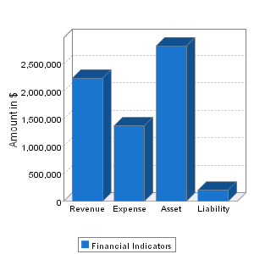
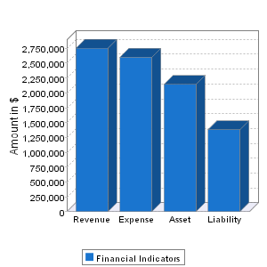
Financial Year 2002 Financial Year 2003 Financial Year 2003
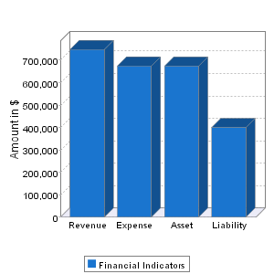

As can be seen from the above financial snapshots, although these three CDCs are often thought of as the top producing CDCs, their budgets are dissimilar and do not provide a framework with which to formulate a model of budgetary efficiency.

Employees and User Units. Approximately 60% of CDCs nationwide employ less than 10 staff members. Again, the majority of CDCs within Cuyahoga County fit this standard. However, two of the top three producing CDCs have significantly more employees with DSCDC employing approximately 26 employees and SVDC employing approximately 25 employees, while TWDC employs only approximately 9 employees.

In addition to determining the number of employees in each of these three CDCs, user units were also calculated as the ratio of the number of employees to the number of households in the area served. We determined that DSCDC’s user unit figure to be 0.0039, SVDC’s user unit figure to be 0.0021, and TWDC’s user unit figure to be 0.0027. This provides the most useful figure in analyzing these three CDCs as they are the most similar of figures determined thus far.

Regionalism, Mergers or Collaboration?

Obviously Cleveland’s CDCs are currently not organized in the most efficient of manners—as mentioned above, there are often many CDCs in one neighborhood and sometimes even more in a given ward and most of them offer the same services. John Emmeus Davis, in an article written for Shelterforce, described a situation such as Cleveland’s as follows:

Some communities have multiple nonprofits of varying size serving a similar geographic area, producing a modest but respectable number of housing units, competing for constituents, funds and development opportunities and struggling to survive. The organizations that find themselves in this uncomfortable situation often confront a special set of challenges. The loss of a single staff person, the delay of a single project or the adverse decision of a single funder can threaten not only their short-term chances for success, but also their long-term prospects for survival.

The question then becomes, what can these CDCs do in order to survive, remain efficient, and continue to produce much-needed affordable housing units and social services for the communities in which they operate? Are these CDCs necessary at all or should they be allowed to become obsolete?

First and foremost, even Cleveland’s government officials agree that CDCs are a necessary component to a successful city. In a recent visit to the MUPDD Capstone Class, Chris Ronanye, then the City Planning Director, stated that neighborhood development corporations are really doing the city government’s work. What, then, can be done to rectify the tangled web of CDC services areas and duplicated services? There are many options available CDCs, ranging from simple collaborations to complete mergers, or perhaps even regionalism.

However, CDCs are unique entities in the business world. They are place-based and are often centered around one community or neighborhood. While we focused primarily on physical capital during the research phase of this project, we have always understood that CDCs are also engaged in building social capital. Therefore, we feel that regionalism—whether it is a regionalized city CDC, one-county CDC, or multiple-county CDC—is not the best option. If CDCs were regionalized in some way, they would run the risk of not reaching the needs of their constituents in the various Cleveland neighborhoods. This is only backed up by the fact that our research demonstrated a high level of concentration of CDCs in particular neighborhoods while others, like Kamm’s Corners, only had one CDC to cover the entire neighborhood—some neighborhoods, in particular lower income neighborhoods, prove to require greater attention than others, and a regionalized CDC would not be able focus as much attention towards these neighborhoods as smaller CDCs might.

The Case for Merging and Collaboration:

Research regarding modern CDCs was funded by the Fannie Mae Foundation in 2003 and conducted by William Rohe, Rachel Bratt, and Protip Biswas. This research found that downsizing, mergers, and failures of CDCs are prevalent across the nation. While unable to determine a concrete number, the research found that at least 103 CDCs experienced one of these changes during the period of 2000 through 2002—46 of those had failed, 41 had downsized significantly, and 16 were involved in mergers.

This research further identified six contextual factors and six organizational factors nationwide that led to such changes in the CDC environment, identified below.

Contextual Factors:
1. Changes in local housing markets including weakened demand for CDC-owned or CDC-managed properties or strong markets that made it difficult for CDCs to acquire land;
2. Increased number of CDCs, which in turn increased competition for funding;
3. Changes in local government policies such as less interest in development of affordable housing, which in turn led to funding cuts;
4. Intermediaries and funders began pressuring CDCs to merge;
5. Lack of local support groups that led to strained and limited communication between CDCs and funders; and
6. Lack of trust among the various CDCs.

Organizational Factors:
1. Narrower focus of some CDCs made them vulnerable to change;
2. Over-reliance on a single source of funding;
3. Internal management problems;
4. Lack of staff and/or board capacity;
5. Poor communication within CDCs, among CDCs, between CDCs and funders, and between CDCs and city officials; and
6. Lack of community support.

While this research found that CDC downsizing or failure negatively impacted the local communities they served, positive impacts were associated with CDC mergers. Negative impacts of downsizing and failure included:

1. Less confidence from the public and private sectors in the remaining CDCs as service providers;
2. Substantial drop in affordable housing production;
3. Loss of existing affordable housing;
4. Neighborhood instability, including an increase in vacant and boarded up properties, which negatively impacted the quality of life and real estate values in the community; and
5. Distress and confusion among the inhabitants of the properties involved.

On the other hand, CDC mergers were found to have positive impacts in the area served, including an increase in organizational capacity and fund raising capabilities, a reintroduction of community organizing and advocacy, an overall more efficient use of resources, and a more holistic view of the neighborhood served. Only one negative impact associated with a CDC merger was identified – a possible high level of conflict associated with the merger process itself.

In a recent online Knowledgeplex chat, Ellen Lazer, Executive Director of the Neighborhood Reinvestment Corporation, listed the positive effects of mergers between CDCs as follows: savings based on economies of scale and increased efficiency, more visibility and increased exposure, higher staff quality and retention because of better salaries and benefits, and broader ranges and depths of services.

Further research funded by the Fannie Mae Foundation and conducted by David La Piana, a consultant on nonprofit mergers and alliances, found that while nonprofit mergers may be the result of one or more CDCs facing challenges such as the ones listed above, mergers and other varieties of partnerships are becoming the norm for CDCs that simply wish to gain strategic advantages. La Piana found a range of partnership options available for nonprofits, such as collaborations, joint alliances, and integration, with mergers being one option. La Piana created “The Partnership Matrix” which explains these options in further detail. “The Partnership Matrix” includes collaboration options ranging from sharing information, pooled purchasing, all the way to the most integrated of options—the merger, where two or more CDCs combine accounting and administrative services, boards, management, and programs.

According to La Piana, the process for CDC mergers should include the following steps: 1) board authorization and resolution; 2) a joint negotiations committee; 3) development of an agenda; 4) negotiation of issues; 5) due diligence regarding each organizations financial condition; 6) decision making on whether a merger is in the best interest of all parties; and 7) implementation planning. La Piana also identified several factors that lead to successful mergers, including having a staff or board member advocating for the alliance, positive past experiences with collaborations, board support and encouragement, organizational risk-taking, and positive board-executive relations.

When considering a merger, CDCs must take into account the various challenges they will inevitably face—while residents will most likely be supportive of a merger between two CDCs who serve the same neighborhood, CDCs serving different neighborhoods may be faced with adversity from residents concerned with a possible loss of services. According to La Piana, mergers are most successful when entered into freely between two or more strong organizations, and only after they make the case regarding both the strategic advantages of the merger and the protections that will ensure neighborhood support.

Recommendations:
Because of Cleveland’s overwhelming lack of CDC organization and duplication of CDC efforts, we feel that mergers between two or more CDCs are the most proactive solution to an impending crisis of closing multiple CDCs. However, there is no neat formula to dictate which CDCs should merge or when they should merge. Rachel Bratt, Professor in the Department of Urban and Environmental Policy and Planning at Tufts University, has stated, “[T]here is no fixed number (of CDCs that a particular region can support). But markets change and the CDCs working in that area need to be aware of how the number of groups is impacting their ability to do development.”

We attempted to determine a number of ways to calculate which CDCs should merge. While we cannot come up with a definite formula for this process, we have identified three different models based on demographic information, the top three producing CDCs, and neighborhood boundaries.

Demographic Model. According to Ronayne, CDCs are the arm of city government in Cleveland. Cleveland is divided into 21 wards based on population. We have determined that one way in which Cleveland CDCs could merge would include merging to create 21 CDCs in total that follow the 21 ward boundaries.

Working of that original demographic model, CDCs could alternatively merge to create CDCs with roughly similarly sized service areas in terms of square miles or with roughly the same number of households.

While the demographic model would most definitely eliminate some competition for funding, it seems too arbitrary of a way to organize CDCs—this is the perhaps the most dangerous model because it would inevitably create fear and confusion among neighborhood residents who would believe they lost services and individual attention, in fact, probably would lose many services and much individual attention.

Efficiency Model. As mentioned above, many people believe that DSCDC, SVDC, and TWDC are the most productive of Cleveland’s CDCs. Working with that assumption, we determined that another alternative method for how Cleveland CDCs could merge would include determining similarities among these three CDCs with the hopes that they would be similar and would a model for the goals of a merging process. As pointed out above, each of these three CDCs have dissimilar budgets and numbers of employees with DSCDC and SVDC being the most similar. Below is a chart of even further demographic information regarding the service areas of these three corporations and the City of Cleveland and Cuyahoga County for reference.

Efficiency Model: Demographics of Top 3 Producing CDCs
 |  |  | Detroit Shoreway Community Development Corporation | Slavic Village Development Corporation | Tremont West Development Corporation | Cleveland | Cuyahoga County
Service Area |  |  | Detroit Shoreway Neighborhood | North and South Broadway Neighborhoods | Tremont Neighborhood
Population |  | 1990 | 18,585 | 29,773 | 8,859 | 505,634 | 1,412,140
 |  | 2000 | 17,382 | 30,524 | 8,163 | 478,403 | 1,393,978
 |  | % Change | -6.5 | 2.5 | -7.9 | -5.4 | -1.3
 | No. of Households | 2000 | 6,715 | 11,999 | 3,302 | - | -
Economic Status | % of Individuals with income below poverty level | 1990 | 39.1 | 26.3 | 47.2 | 28.7 | 13.8
 |  | 2000 | 35.6 | 21.75 | 37.6 | 26.3 | 13.1
 | Median HH Income | 1990 | $16,452 | $16,958 | $15,312 | $23,133 | $37,112
 |  | 2000 | $21,138 | $23,615 | $21,496 | $25,928 | $39,168
 | Unemployment Rate | 1990 | 16.5 | 11.83 | 19.3 | 14 | 7.5
 |  | 2000 | 12.4 | 12.06 | 11.2 | 11.2 | 6.2
Housing | No. of Housing Units | 1990 | 8,052 | 14,296 | 4,160 | 224,316 | 604,538
 |  | 2000 | 7,772 | 13,833 | 3,949 | 215,856 | 616,903
 | % of Vacant Housing Units | 1990 | 12.6 | 11.98 | 16.6 | 10.9 | 6.8
 |  | 2000 | 13.6 | 13.26 | 16.4 | 11.7 | 7.4

As can be seen from reviewing the demographic information above, while DSCDC’s and SVDC’s demographic information appear somewhat similar, TWDC remains distinct, only further proving the facts that CDCs can be judged only on an individual basis and that there is no set formula for efficiency.

However, user unit figures for these three CDCs, discussed above, are similar. Therefore, we have determined that any merger process between CDCs should be carefully attentive to user units.

Neighborhood Model. Another alternative method for organizing merged CDCs would be to base the organization around Cleveland’s pre-existing neighborhoods. We have determined that this may be the best approach for Cleveland, since Cleveland has very distinct neighborhoods and particularly because CDCs are highly place-based. If CDC service areas followed Cleveland’s neighborhood boundaries, there would be 36 CDCs—a significant decrease in the number of CDCs currently in operation. Also, it is important to note that one of the more successful CDCs, SVDC, actually operates in two neighborhoods—North and South Broadway—and is one of the top producing CDCs in the city. Therefore, we have determined that while it may be best to follow neighborhood boundaries, not even this model for merging is the one neat formula to follow.

Conclusion:
After researching and analyzing data regarding CDCs within Cuyahoga County, it is obvious that merging CDCs within the City of Cleveland is the best step towards an efficient, productive, and overall successful CDC environment. The amount of overlap and duplication supports this argument. In order to determine which should CDCs merge, many things will come into account, including first and foremost the community interests and needs. We have identified three models for merging CDCs: the demographic model, effectiveness model, and neighborhood model. While neither of these models supplies a neat formula for determining whether and when a merger should take place, they do offer suggestions as to what should be taken into account when deciding to merge. At the very least, we feel that CDCs should become aware of the overwhelming amount of overlap and duplication taking place and begin to collaborate efforts, whether they combine offices or simply share information, so that a more effective CDC environment can be set in motion for the City of Cleveland.
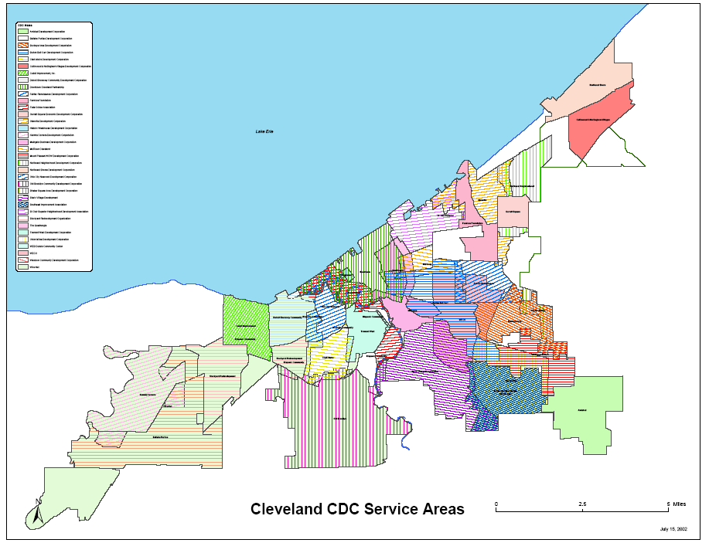
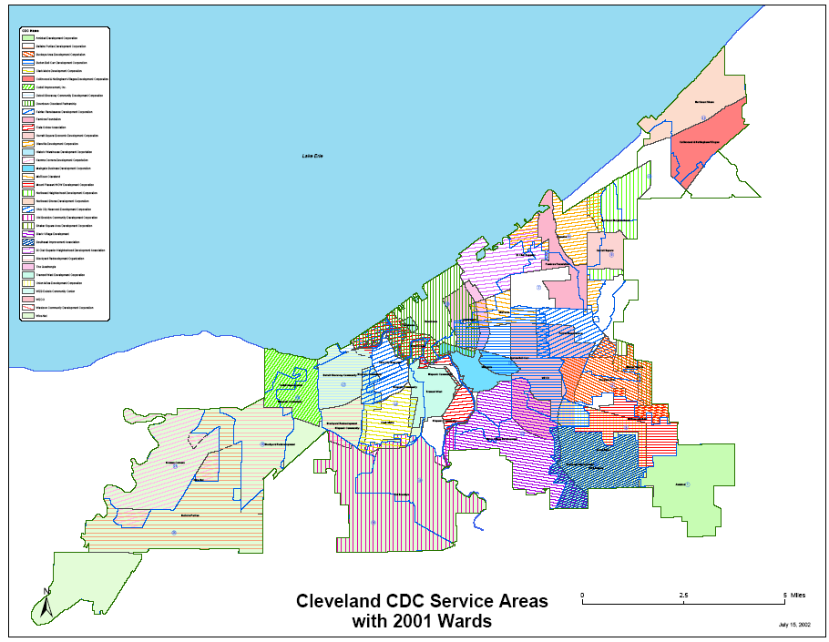
Maps courtesy of http://www.nhlink.net/maps. Larger map can be viewed at this website.

http://www.bos.frb.org/about/ar/ar2001/01essay.pdf
http://www.bos.frb.org/about/ar/ar2001/01essay.pdf
http://www.bos.frb.org/about/ar/ar2001/01essay.pdf
http://www.bos.frb.org/about/ar/ar2001/01essay.pdf
http://www.bos.frb.org/about/ar/ar2001/01essay.pdf; http://curs.unc.edu/cdcreport.pdf
http://curs.unc.edu/cdcreport.pdf
http://www.cndc2.org/
http://cando-exp.case.edu/.
See Map 1, Cleveland CDC Services Areas, attached hereto. http://www.nhlink.net/maps/
See Map 2, Cleveland CDC Service Areas with 2001 Wards, attached hereto. http://www.nhlink.net/maps/
http://www.bos.frb.org/about/ar/ar2001/01essay.pdf.
http://curs.unc.edu/cdcreport.pdf.
DSCDC is in the process of producing a development of approximately 330 units, SVDC has produced 245 housing units over the past five years, and TWDC has produced 136 units over the past five years.
All financial snapshots taken from http://www.guidestar.org.
http://www.bos.frb.org/about/ar/ar2001/01essay.pdf.
Although it was suggested to calculate user units as the ratio of dollars spent or number of employees to the population within a service area, we felt it was best calculated as the ratio of the number of employees to the number of households within a service area. We reasoned that CDCs do not spend money per resident, instead they spend money per project, and therefore we did not feel that the ratio of dollars to population was the best figure. Also, we felt that since we were focusing on housing production, we should use the ratio of the number of employees to the number of households since, arguably, housing production is more closely related to the number of households than to pure population.
http://www.nhi.org/online/issues/129/merger.html.
http://curs.unc.edu/cdcreport.pdf
http://curs.unc.edu/cdcreport.pdf
http://curs.unc.edu/cdcreport.pdf.
Further, Lazer offers that the entire merger process can take anywhere from a year to a couple of years. http://www.nw.org/network/newsroom/speeches/pdf/kplex_chat_transcript_102402.pdf..
http://www.fanniemaefoundation.org/programs/hpd/pdf/hpd_1401_LaPiana.pdf.
http://www.fanniemaefoundation.org/programs/hpd/pdf/hpd_1401_LaPiana.pdf.
http://www.fanniemaefoundation.org/programs/hpd/pdf/hpd_1401_LaPiana.pdf.
http://www.fanniemaefoundation.org/programs/hpd/pdf/hpd_1401_LaPiana.pdf.
http://www.fanniemaefoundation.org/programs/hpd/pdf/hpd_1401_LaPiana.pdf.
http://www.fanniemaefoundation.org/programs/hpd/pdf/hpd_1401_LaPiana.pdf
http://www.fanniemaefoundation.org/programs/hpd/pdf/hpd_1401_LaPiana.pdf
http://www.nw.org/network/newsroom/speeches/pdf/kplex_chat_transcript_102402.pdf

