Jennifer Porter
April 5, 2005
Budget Data Analysis – Nonprofits

BUDGET ANALSYIS FOR CDCs WITHIN CUYAHOGA COUNTY

Budget Data. The annual operating budgets of CDCs nationwide range from under $100,000 to over $2 million, with a median annual operating budget falling between $200,000 and $399,000. The budgets of Cuyahoga County’s CDCs fit this standard.

Budget information for CDCs within Cuyahoga County was collected from www.guidestar.org. Only the budgets of those CDCs that are thought to be the most efficient and productive will be explored further, with the assumption that these budgets are models for the remaining CDCs. Most people in the nonprofit business believe that there are three impressively successful CDCs in Cleveland --Detroit Shoreway Community Development Corporation (DSCDC), Slavic Village Development Corporation (SVDC), and Tremont West Development Corporation (TWDC). Below are financial snapshots of each of these three organizations.

Detroit Shoreway Slavic Village Tremont West
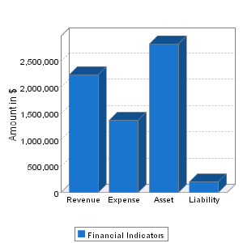
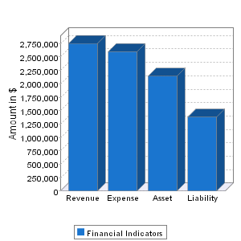
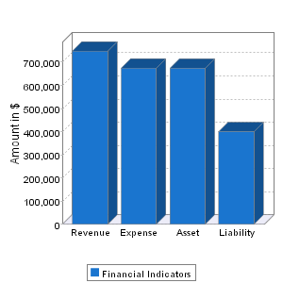
Financial Year 2002 Financial Year 2003 Financial Year 2003

As can be seen from the above financial snapshots, although these three CDCs are often thought of as the top producing CDCs, their budgets are dissimilar and do not provide a framework with which to formulate a model of budgetary efficiency.

Employees and User Units. Approximately 60% of CDCs nationwide employ less than 10 staff members. Again, the majority of CDCs within Cuyahoga County fit this standard. However, two of the top three producing CDCs have significantly more employees with DSCDC employing approximately 26 employees and SVDC employing approximately 25 employees, while TWDC employs only approximately 9 employees.

In addition to determining the number of employees in each of these three CDCs, user units were also calculated as the ratio of the number of employees to the number of households in the area served. We determined that DSCDC’s user unit figure to be 0.0039, SVDC’s user unit figure to be 0.0021, and TWDC’s user unit figure to be 0.0027. This provides the most useful figure in analyzing these three CDCs as they are the most similar of figures determined thus far.

http://www.bos.frb.org/about/ar/ar2001/01essay.pdf.
http://curs.unc.edu/cdcreport.pdf.
DSCDC is in the process of producing a development of approximately 330 units, SVDC has produced 245 housing units over the past five years, and TWDC has produced 136 units over the past five years.
All financial snapshots taken from http://www.guidestar.org.
http://www.bos.frb.org/about/ar/ar2001/01essay.pdf.
Although it was suggested to calculate user units as the ratio of dollars spent or number of employees to the population within a service area, we felt it was best calculated as the ratio of the number of employees to the number of households within a service area. We reasoned that CDCs do not spend money per resident, instead they spend money per project, and therefore we did not feel that the ratio of dollars to population was the best figure. Also, we felt that since we were focusing on housing production, we should use the ratio of the number of employees to the number of households since, arguably, housing production is more closely related to the number of households than to pure population.

