2005 Budget
Fire Department
2004 marked the first year that the Fire Department was able to balance their budget since the department went full time in the late 1990's. Although this was a tremendous accomplishment, it is a very short-lived reality. Due mostly to shortages in staffing, the Fire Department will continue to have extremely high overtime costs in order to cover shifts and maintain adequate staffing to serve Brunswick. Despite reducing their purchased services and supply/materials by $16,180 in 2005, the Fire Department will shift $240,000 from their capital fund in order to break even on operations.
Police Department:
The Police Department is funded within the General Fund and their special revenue fund. The special revenue fund accounts for the portion of wages that is attributed to the income tax allocation that was voted on by the Residents in 1994. This amount represents only 22.9% of the department’s total operating and capital expenditures. The remaining 77.1% is General Fund. The following table shows the funding.

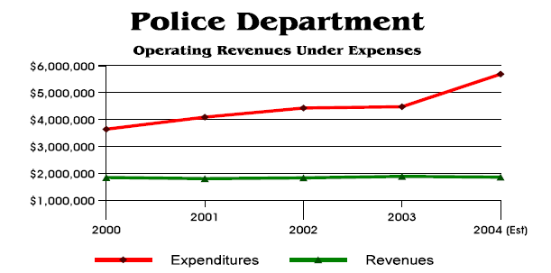

These funding shortfalls are the major reason why the General Fund’s cash balance from year to yearn has been decreasing. Simply put, the cost of operating the Police Department at the current level of funding is far in excess of the revenue sources meant to cover those costs.
The 2005 budget does not call for any increases or hiring of personnel with the exception of the Brunswick Area Television Operation (Fund #123). The Cable Operation has budgeted for the addition of one full-time production assistant.

General Fund: Final Information
The City’s Income Tax is the largest source of revenue for the General Fund, Police Operations, Fire Operations, Street Maintenance & Repair Operations, Parks Operations and the General Debt Obligations of the City. Income tax is collected from three major tax paying groups who are residential (51.6%), business withholdings (44.0%) and corporate earnings (4.40%). Having a primarily residential income tax base means that the city is directly impacted by the local and regional job -market. Since 2001, the local and regional job markets decline has resulted in the City’s main revenue source to flatten.
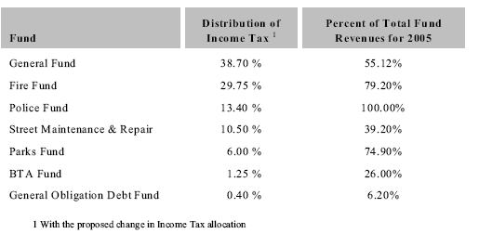

General fund Revenue Percent By Source

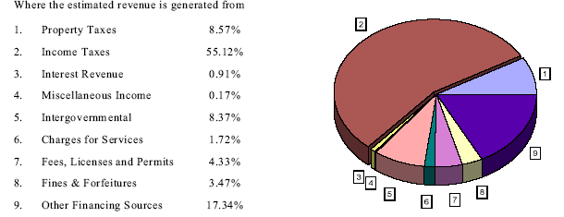

General Fund Expenditure
The General Fund expenditures are broken down in several basic program areas. Based upon the following chart represented below, Security of Persons and Property consists of 24.83 % of the General Fund expenditures.
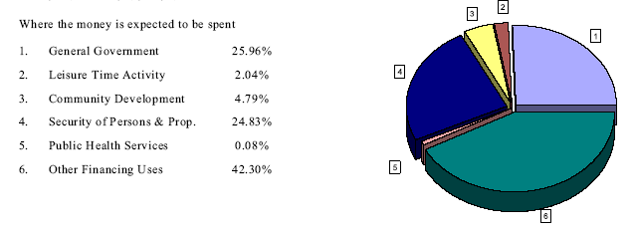

Income Tax Revenues vs. Operating Expenses

The following graph shows the General Fund’s income tax revenues as compared to the operating expenditures for the past five years. This graph provides another visual aid to demonstrate that the General Fund is significantly under-funded with regard to the City’s income tax revenue proceeds.

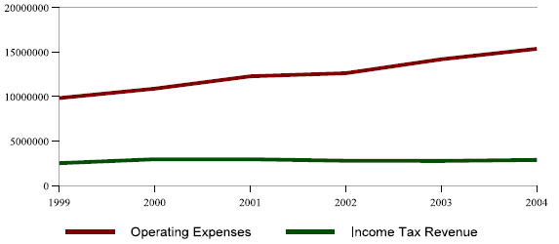

2005 Fund balance

The following charts represent a five-year cash history for the general fund and Fire Fund. As clearly shown, the financial downturn of the economy along with several other factors has resulted in the reduction of these cash balances.
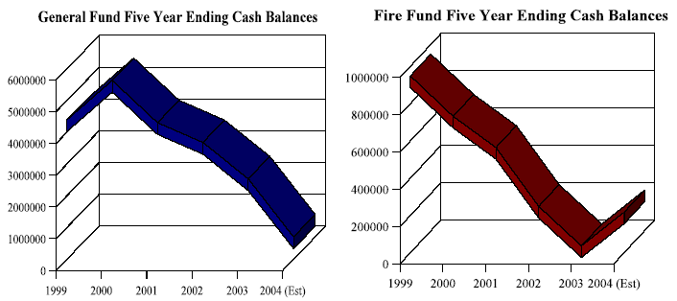

Summary of Budget: Safety (Fire & Police)

► 2005 Grand Total of All Funds
Classification | Estimated | Budget Appropriation | Ratio of Total Budget
Total | 41,011,941.40 | 47,083,617.44 | 100 %
General Fund | 15,260,680.18 | 15,127,621.09 | 32.1
Special Revenue Funds | 11,781,691.85 | 12,790,118.55 | 27.2
Enterprise Funds | 1,657,248.00 | 1,673,168.00 | 3.6
Capital Projects | 11,167,905.37 | 16,187,254.80 | 34.4
Debt Service Funds | 711,416.00 | 817,455.00 | 1.7
Agency Funds | 433,000.00 | 488,000.00 | 1.0

► 2005 Budget Appropriation of Safety (Police and Fire)
Classification | Budget Appropriation | Fund Types | Ratio Of Grand Total
Total | 8,171,431.00 |  | 17.4 %
Police Department | 3,630,192.00 | General Fund | 7.7
Police Salaries Fund | 1,250,000.00 | Special Revenue Fund | 2.7
Fire Fund | 3,291,239.00 | Special Revenue Fund | 7.0

►General fund Revenues
- Revenues
Classification | 2005 | 2004 | 2003 | 2002 | 2001
Total | 15,152,880.18 | 12,343,932.23 | 12,474,832.09 | 12,225,651.95 | 12,546,420.82
Property Tax | 1,289,255.00 | 1,483,255.48 | 1,457,385.85 | 1,445,953.69 | 1,222,057.77
Income Tax | 8,351,793.00 | 7,478,333.31 | 7,911,142.05 | 7,932,478.87 | 7,875,880.92
Inter-Gov (state) | 1,022,703.00 | 877,068.00 | 1,357,196.04 | 1,215,694.94 | 1,392,820.59
Other ¹ | 4,489,129.18 | 2,505,275.44 | 1,749,108.1 | 1,631,524.45 | 2,055,661.54

¹ Charges for service, permits, intergovernmental -local, interest earnings, miscellaneous and fines & forfeitures

- Ratio
Classification | 2005 | 2004 | 2003 | 2002 | 2001 | Average
Total | 100 | 100 | 100 | 100 | 100 | 100
Property Tax | 8.5 | 12.0 | 11.7 | 11.8 | 9.7 | 10.7
Income Tax | 55.1 | 60.6 | 63.4 | 64.9 | 62.8 | 61.4
Inter-Gov (state) | 6.7 | 7.1 | 10.9 | 9.9 | 11.1 | 9.1
Other ¹ | 29.6 | 20.3 | 14.0 | 13.3 | 16.4 | 18.7

► Appropriation Budget of Police Department

- Dollars
Classification | 2005 | 2004 | 2003 | 2002 | 2001
Total | 3,630,192.00 | 2,612,351.02 | 3,234,303.17 | 3,109,798.02 | 2,711,487.22
Operations | 3,422,339.00 | 2,159,146.73 | 3,191,496.26 | 2,923,371.19 | 2,659,897.87
Capital out Lay | 207,853.00 | 453,204.29 | 42,806.91 | 186,426.83 | 51,489.35

- Ratio: Appropriation Budget of Police Department to Total General Fund
Classification | 2005 | 2004 | 2003 | 2002 | 2001
Total (%) | 23.8 | 22.8 | 22.4 | 24.2 | 19.5

** 2005 Total General Fund: $ 15,227,621.09 (Operations: 14,775,274.75, Capital Outlay: 352,346.34)

►Special fund Revenues and Budget appropriation
- Revenues of Police Salaries Fund
Classification | 2005 | 2004 | 2003 | 2002 | 2001
Total | 1,250,000.00 | 1,111,731.00 | 1,021,564.37 | 1,028,307.06 | 974,948.37
Income Taxes  (13.40%) | 1,250,000.00 | 1,111,731.00 | 1,021,564.37 | 1,028,307.06 | 974,948.37

- Budget Appropriation of Police Salaries Department
Classification | 2005 | 2004 | 2003 | 2002 | 2001
Total
Police salaries | 1,250,000.00 | 1,023,546.62 | 1,035,622.91 | 996,638.42 | 947,346.42

- Revenues of Fire Fund (Dollars)
Classification | 2005 | 2004 | 2003 | 2002 | 2001
Total | 3,014,100.00 | 2,636,627.40 | 2,655,438.92 | 2,615,912.92 | 2,404,293.02
Charge for Service | 360,000.00 | 461,359.44 | 322,485.67 | 315,254.53 | 322,449.50
Income Tax (29.75%) | 2,388,800.00 | 2,151,630.05 | 2,268,025.36 | 2,282,995.17 | 2,064,596.58
Inter-governmental  State | 10,000.00 | 9,502.83 | 11,069.81 | 16,716.42 | 17,001.95
Miscellaneous | 13,000.00 | 14,135.08 | 3,858.08 | 946.80 | 244.99
Transfer / Advances | 243,100.00 | 0.00 | 50,000.00 | 0.00 | 0.00

- Ratio (%)
Classification | 2005 | 2004 | 2003 | 2002 | 2001
Total | 100 | 100 | 100 | 100 | 100
Charge for Service | 11.9 | 17.5 | 12.1 | 12.1 | 13.4
Income Tax (29.75%) | 79.3 | 81.6 | 85.4 | 87.3 | 85.9
Inter-governmental - State | 0.3 | 0.3 | 0.4 | 0.6 | 0.7
Miscellaneous | 0.4 | 0.5 | 0.1 | 0.0 | 0.0
Transfer / Advances | 8.1 | 0.0 | 1.0 | 0.0 | 0.0

- Budget Appropriation of Fire Department
Classification | 2005 | 2004 | 2003 | 2002 | 2001
Total | 3,291,239.00 | 2,141,535.91 | 2,866,995.34 | 2,931,932.46 | 2,571,559.73
Personal Service | 1,801,520.00 | 1,250,581.61 | 1,629,341.15 | 1,607,789.90 | 1,461,706.98
Fringe Benefit | 973,380.00 | 666,725.96 | 783,262.92 | 743,699.09 | 626,373.51
Purchased Services | 203,762.00 | 165,872.05 | 206,651.92 | 201,749.65 | 186,124.26
Supplies & Mat | 37,477.00 | 30,145.24 | 35,893.28 | 25,213.72 | 38,995.52
Transfers Out | 0.00 | 0.00 | 137,573.76 | 190,000.00 | 146,650.00
Equip & Capital | 275,100.00 | 28,211.05 | 74,272.31 | 163,480.10 | 115,709.46

- Ratio (%)
Classification | 2005 | 2004 | 2003 | 2002 | 2001
Total | 100 | 100 | 100 | 100 | 100
Personal Service | 54.7 | 58.4 | 56.8 | 54.8 | 56.8
Fringe Benefit | 29.6 | 31.1 | 27.3 | 25.4 | 24.4
Purchased Services | 6.2 | 7.7 | 7.2 | 6.9 | 7.2
Supplies & Mat | 1.1 | 1.4 | 1.3 | 0.9 | 1.5
Transfers Out | 0.0 | 0.0 | 4.8 | 6.5 | 5.7
Equip & Capital | 8.4 | 1.3 | 2.6 | 5.6 | 4.5

