Mapping shared drive for PDD 611 Capstone

Right click on the “My Computer” icon on your desktop.

Single click on “Map Network Drive”, you should see the following:

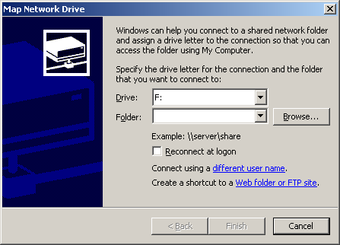

In the “Drive” box, pull down to the drive letter you want to map – you can choose any letter that is not already in use.

In the Folder box, type \\wolf\pdd611_capstone

Check the “Reconnect at logon” box if you want this drive to automatically map every time you log onto the system.

(Over)

Now the box should look like the one below:

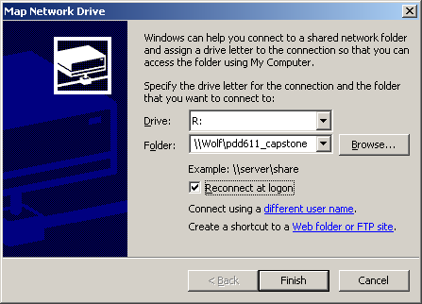

This will map the PDD 611 file location as the “R:\” drive, and will continue to do it every time you log in.

Now click on the “Finish” button. A windows should open that will allow you to access the PDD 611 Capstone files. Remember, if you are a student you can read from the drive, but only your instructor can put files on the drive.

Contact the STSS on duty if you have any problems mounting the drive or accessing the files.

