PDD 611 – Planning Capstone
SEWER AND WATER
Assignment Two

Group Members:
Ernest Abrogar
Steve Baucher
Tim Kobie
Sean McDermott
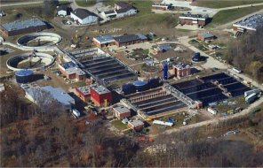

Greater Cleveland Sewer and Water…….
For Dummies (Or Urban Planning Students)

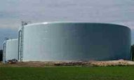

April 5, 2005

TABLE OF CONTENTS

1.0 introduction

2.0 water and sewer systems by county
2.1 cuyahoga county (Kobie)
2.2 geauga county (baucher)
2.3 lake county (baucher)
2.4 lorain county (mCdermott)
2.5 medina county (mcdermott)
2.6 portage (kobie)
2.7 summit county (abrogar)

3.0 other metropolitan water sewer service providerS (KOBIE)

4.0 FINDINGS AND CONCLUSIONS

1.0 INTRODUCTION

Civilization can be measured by its infrastructure. Northeast Ohio should be very proud of its sewer and water infrastructure. While not always a hot topic, sewer and water provide services to a population that shouldn’t have to think twice about the quality of water they are drinking, or whether or not their sewage is damaging the environment. Northeast Ohio’s sewage and drinking water systems have served our region well, now it is time to analyze if they are serving the population efficiently.

This assignment takes a broad look at water and sewer separately. This introduction will give you the knowledge to understand the basic workings of each system, and the conclusion will suggest some possible ways to create more efficient systems, if possible. Between the two an assessment of the water and sewer systems in each county in the region, Cuyahoga, Geauga, Lake, Lorain, Summit, and Portage, is provided.

The majority of the region receives its drinking water from Lake Erie. The water is taken from the Lake in large pipes and treated at several treatment plants. The water is pressurized in pipes (mains) and sent to houses and businesses. Those who do not receive “city” water in this manner probably receive their water by means of a private well system which is drilled somewhere on their property. Water is pumped from the well, sometimes softened, and pumped into plumbing of the house or business. This occurrence is more common in rural and farm settings.

Waste water is the byproduct of most of our domestic activities involving water. Laundry, showering, dish washing, all produces waste water. This water enters drains and into sanitary sewers which collects the water and flows it to waste water treatment plants. The treatments plants treat the water, usually to levels of human consumption, and return it to streams or the Lake. Usually those who have “city” water also have sewer service. For those who do not have sewer service, private septic systems take waste water from the individual’s house. These septic systems require much maintenance and often fail or are in need of costly repairs. Septic systems are the responsibility of the private homeowner.

Whether you are on city water, well water, sewer, or septic, you inherently want the most efficient system at the cheapest cost. The question we will attempt to answer in the Conclusion with the data collected is whether or not regionalism can provide a more efficient water and sewer system.

The following section provides a breakdown on a county level the workings of the various sewer and water facilities within the county.

2.0 water and sewer systems by county

2.1 Cuyahoga County

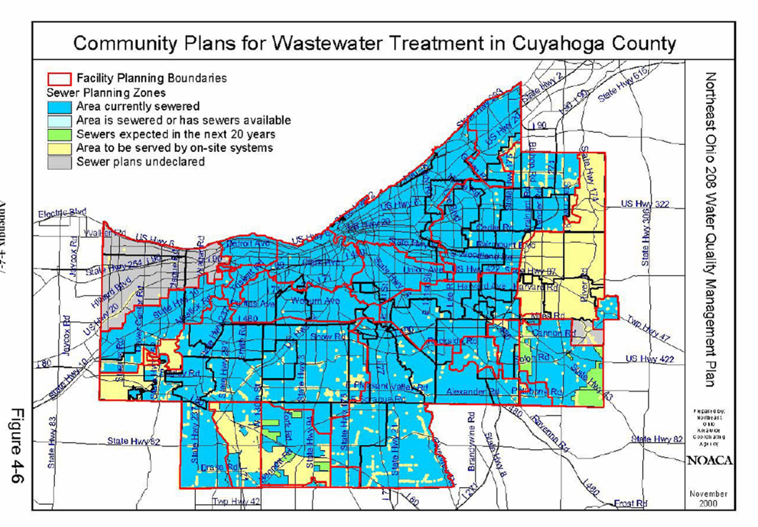
Sewer and water service in Cuyahoga County is provided by two large, regionalized entities for the most part, Cleveland Water and the Northeast Ohio Regional Sewer District. Cleveland Water has approximately 393,000 residential accounts. Rates depend on the level of service provided. Cleveland residents are charged quarterly, $8.13 for the first 1,000 cubic feet and $17.39 for each additional 1,000 cubic feet. Annually, this would be around $170 dollars. Low and 1st High Service Suburbs are charged quarterly, $14.48 for the first 1,000 cubic feet of water and $30.91 for each additional 1,000 cubic feet of water. This translates to about $300 annually. 2nd High Service Suburbs are charged quarterly, $16.72 for the first 1,000 cubic feet of water and $36.48 for each additional 1,000 cubic feet of water. This will be about $360 annually. 3rd High Service Suburbs are charged quarterly, $19.60 for the first 1,000 cubic feet of water and $41.88 for each additional 1,000 cubic feet of water. A water bill for one of these residents would be about $413 annually. To put these costs into perspective, here are annual water rates from other metro areas: Twin Cities $174, Chicago $129, Boston $411, and Cincinnati $307. So while Cleveland’s rates are not the highest, they are on the high end.

The Northeast Ohio Regional Sewer District (NEORSD) has 130,000 customers in the City of Cleveland and 192,000 customers in the suburbs. Rates for Clevelanders are $26.20 per 1,000 cubic feet. The rate climbs to $30.95 per 1,000 cubic feet for those living in the suburbs. These rates translate into $314 and $371 annually for sewer service. Comparatively, the City of Euclid charges $34.51 per 1,000 cubic feet or about $414 annually. Euclid has approximately 23,000 residential users, a much smaller number of users but a slightly higher price. City of Euclid and NEORSD infrastructure is relatively old with similar problems such as combined sewer overflow (CSO). It would therefore seem that the NEORSD could absorb a small district like Euclid with minimal additional costs and yet have savings for Euclid. Because the NEORSD is so large and services most of Cuyahoga County, it would make sense to merge those smaller districts into the larger district.

2.2 Geauga County

Brief Demographic Profile:
Geauga County is East of Cuyahoga and South of Lake County; it covers 404 square miles of mostly rolling hills. The majority of the 90,985 residents reside in rural areas. The County has over 31,639 housing units, 24,987 families and more than 1,750 business establishments. The population density is 87/km² (225/mi²). The County consists of seven municipalities; Aquilla, Burton, Chesterland, South Russell, Bainbridge, Chardon, and Middlefield.

Geauga County Water Department:

Geauga County Water Department (GCWD) has only 461 connections to their central water system. Over 90% of the population relies on individual wells. GCWD supplies only 1.45% of Geauga’s housing units. The remaining population is serviced by local municipalities. The municipalities that provide central water are Chardon, Burton, and Middlefield. All of Geauga County’s public water systems are found in Table 1. Map 1 identifies the location of the water stations. Map 2 identifies the communities with public operated central water supply. All suppliers get their water from under ground aquefers.

Table: 1
Source: Geauga County Water Resource Department

The GCWD original operating revenue budget for 2003 was $4,715,051. The actual amount earned for the 2003 fiscal year was $5,166,976. This was broken down by four broad categories; (1) Charges for Services ($3,865,309), (2) Interest ($44,434), (3) Tap-in fees ($375,800), (4) other ($267,026), and (4) Intergovernmental ($614,407).

The GCWD original operating expenses budget was $5,431,433. The final expenses for the fiscal year 2003 were $4,762,790. Final expenses was the summation of; (1) Personal services ($1,711,567), (2) Contractual services ($1,585,090), (3) materials and supplies ($265,855), (4) Other ($116,022), (5) capital outlay ($566,906), (6) Principal Retirement ($271,437), and (7) Interest and Fiscal Charges ($245,913). The GCWD ran a surplus of $404,186

Map 1: County and Municipal operated Central water Facilities Map 2: Areas Served by a Publicly operated Central Water Supply

Sewer Division:
Geauga County Sewer Division (GCSD) provides sanitary sewer service to 2.7% of the County. Of the more than 260 thousand acres in Geauga County, only 7 thousand are sewered. The sanitary facilities in Geauga County are listed in Table 2. There geographical location of the facilities can be found in Map 3. The areas that are serviced by a central operated sanitary sewer system are found in Map 4.

Table 2:
Source: Geauga County Water Resource Department

Map 3: County and Municipal operated Central Sanitary Map 2: Areas Served by a Publicly operated Central Sanitary
Sewer Treatment Plants Sewage System

The GCSD original operating revenue budget for 2003 was $437,800. The actual amount earned for the 2003 fiscal year was $491,445. This was broken down by two categories; (1) Charges for Services $402,056), and (2) Other ($89,389)

The GCSD original operating expenses budget was 618,300. The final expenses for the fiscal year 2003 were 507,985. Final expenses were the summation of; (1) Personal services ($148,917), (2) Contractual services ($181,622), (3) materials and supplies ($30,401), (4) Other ($2,651), and (5) capital outlay ($144,394). The GCSD ran a deficit in the fiscal year 2003 of $16,540.

Table 3 is the annual resedential sewer rates for the municipalities not served by Geauga County. The rate is based on 7,756 gallons per month averge. From the Table 3 sewer rates have remained relatively constant since 1991, however Chardon rates have declined.

Table 3:

2.3 Lake County

Brief Demographic Profile:
Lake County is the smallest of Ohio’s 88 counties. Consisting of 231 square miles and has a population of more than 229,000. Lake County has over 93,000 housing units and more than 5,600 business establishments. Eighteen municipalities reside within the County’s border, and the majority of those have established infrastructure.

Water Division:
Lake County provides water to residential, commercial and industrial customers. Revenue generated through user charge is used for operation, maintenance and capital improvements of the water distribution system. Lake County’s Department of Water is responsible for more than 39,000 customers, which is over 41% of all the households within the County.

To serve all the customers, Lake County Water maintains and operates over 563 miles of water lines, 2 water plants, and 7 water booster stations. The two water stations are Lake County West Aquarius Plant (West) and Water Service Center (East). The Lake County West Aquarius plant serves 80,000 customers in Eastlake, Willoughby, and five surrounding communities. Built in 1985, the plant was designed as a 20 million gallon per day (MGD) Class IV conventional surface water treatment plant. Currently, the plant operates at approximately 11 MGD.

The Bacon Road Water Service Center located in Perry, Ohio is a 6.0 MGD facility, which serves over 13,000 customers in Perry and the surrounding communities. The plant currently operates at approximately 4.0 million gallons per day (MGD). Both the West Aquarius Plant and Water Service Center utilize Lake Erie as its source.

Municipalities currently served by Lake County Water are Concord Twp., Eastlake, Lakeline, Madison, North Perry Village, Painesville Twp., Perry Twp., Perry Village, Timberlane Village, Wickliffe, Willoughby, Willoughby Hills, and Willowick. Three other water providers currently serve the residence of Lake County. Two are local providers; Painesville City Water and Madison Village Water, the third is Consumers Ohio Water, which is strictly a water provider. An agreement among water providers regarding the maintenance and repair of the water lines has been established. Lake County’s Water Division provides the majority of the maintenance and repair of the infrastructure.

The Lake County Water Department’s original operating revenue budget for 2003 was $17,574,303. The actual amount earned for the 2003 fiscal year was $19,202,421. This was broken down by four broad categories; (1) water sales ($17,974,951), (2) fees, permits, and tap- ins ($931,836), (3) charges for service ($197,644), and (4) other operating revenues ($97,990).

The Departments original operating expenses budget was $9,095,545. The final expenses for the fiscal year 2003 were $8,264,591. The figure was the summation of; (1) personal services ($3,070,279), (2) contractual services ($511,943), (3) materials and supplies ($884,634), (4) operating expenses ($2,586,893), and (5) capital outlay ($1,210,842). The Lake County Department of Water ran a $10,937,830 surplus in 2003.

Lake County Sewer Division:

Lake County provides sanitary sewer service to residential, commercial and industrial customers. Wastewater charges are based on water usage, and serve as the major revenue source for financing the operations and maintenance of the wastewater system.
Lake County’s Sewer Department (LCSD) is responsible for nearly 40% of all County households. To meet current demand, they operate 3 wastewater treatment facilities, 40 wastewater pump stations, and more than 817 miles of sewer lines. Their service area includes Grand River, Leory Twp, Concord Twp, Madison Twp, North Perry Village, Perry Village, Painesville Twp, Timberlane Village, Fairport harbor, Mentor, and Mentor-on the-Lake.

The LCSD maintain only their lines. Municipalities not served by the LCSD are responsible for the maintenance and repair of there own lines. The other waste water treatment facilities include; Painesville City WWTP, Madison Village WWTP, Willoughby/Eastlake Wastewater Treatment Plant (W/EWWTP), and the Euclid WWTP.

The LCSD’s 2003 original operating revenue budget was $13,802,631, which was 2.2 million less than the actual amount earned ($14,388,993). The revenue earned breaks down into similar categories mentioned earlier; (1) sewer charges ($12,182,822), (2) fees, permits, and tap- ins ($1,905,374), (3) charges for service ($251,750), and (4) other operating revenues ($49,047).

The operating expenses budgeted for 2003 was $9,742,265, which was slightly over the $9,640,712 that accrued. $4,191,679 was allocated toward personal services, $576,940 was for contractual services, $643,375was for materials and supplies, $3,255,709 was for other operating expenses, and $973,009 was for capital outlay. The LCSD experienced a net income of $4,748,281.

Table 1 is the sewer rates for those communities not serviced by Lake County Sewer Department. Rates have remained relatively consistent since 1991.

2.4 Lorain County

Lorain County, just to the west of Cuyahoga County is a mixture of rural farmland and urban and suburban landscape which in the recent years has vastly grown. The County’s residents are served by several entities for their water and sewer needs. Comparatively, the residents of Lorain County benefit from their proximity to Lake Erie with very reasonable water and sewer rates.

For the most part, municipalities purchase water from a few sources and the majority of the villages and townships of the county are supplied water from a central authority. Overall, the water system of the county is quite impressive, and shows that a first step towards regionalism has already been taken.

Avon Lake, Amherst, Elyria, Lorain, Oberlin, and Wellington all operate drinking water systems. These providers often sell water to their neighboring cities who in turn maintain their own mains and perform their own billing.

The Rural Lorain County Water Authority (RLCWA) provides drinking water to vast portions of Lorain and Medina Counties. They purchase the majority of their water from the Avon Lake filtration plant and disperse it to 19,000 customers most of whom live in rural areas. The water authority is the outcome of a combined effort of many villages and townships of Lorain and Medina Counties.

Within the county, there does not seem to be large overlaps in service areas based upon the plant sizes that each of the separate entities run. The Avon Lake plant’s capacity allows for it to sell the majority of the 21 million gallons per day average of treated water it produces to the RLCWA and its neighbors, Avon, Sheffield, Sheffield Lake, and North Ridgeville.

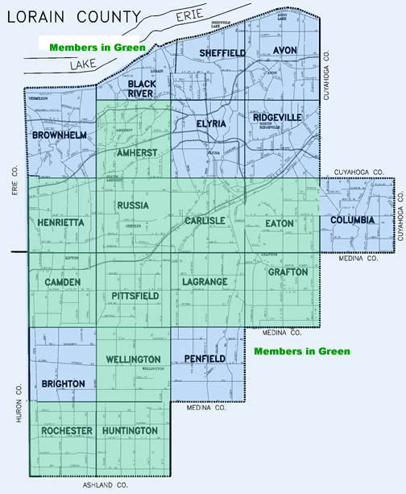
Lorain County’s sewage collection systems are not as impressive as their water distribution systems. While many of municipalities run their own waste water treatment plants, most of the villages and townships have no sanitary sewer service, forcing residents to use septic methods which have environmental consequences. Within the County, Amherst, Avon Lake, Elyria, Grafton, LaGrange, Lorain City, Oberlin, North Ridgeville (the French Creek Plant), Vermilion, and Wellington run their own plants, while the Lorain County Sanitary Engineer runs several small package plants that serve small housing developments.

Like the water system, those municipalities which operate WWTP often accept flow from their neighbors. Due to the fact that the rural areas of the County have no service, a recent push has created LORCO, a partner to RLCWA which has as its mission to sewer the rural portions of the County. LORCO is an affiliation between Amherst, Camden, Carlisle, Eaton, Elyria, Grafton, Henrietta, Huntington, LaGrange, New Russia, Pittsfield, Rochester, and Wellington Townships, in addition to Wellington, South Amherst, Kipton, and Rochester Villages. Like the Northeast Ohio Regional Sewer District, LORCO will be a political subdivision of the State of Ohio, allowing it many advantages in terms of taxing and funding. This example of regionalism within the County shows how a group of entities can work together towards a common goal.

2.5 Medina County

The water and sewer systems of Medina County are quite impressive. They are both helping to fuel the housing boom in the quickly suburbanizing county to the southwest of Cleveland.

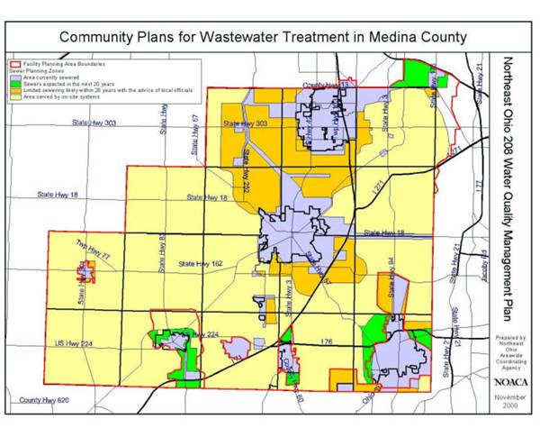
The majority of the water used by the residents of the County is purchased through the Rural Lorain County Water Authority, which in turns purchases water from Avon Lake. Wadsworth and Brunswick are the exceptions to the rule. Wadsworth has its own water filtration plant which pulls its water from an aquifer and Brunswick is actually part of the Cleveland Water Department. Wadsworth also maintains its own distribution system. The vast majority of the County is under the jurisdiction of the Medina County Sanitary Engineer.

The Sanitary Engineer can be looked upon as another small example of regionalism, pooling resources to care for a large system of infrastructure, both sewer and water, rather than have individual villages and townships take on the burden.

The County’s sanitary sewer system is quite impressive. They have laid and sized their mains and located their treatment plants for many years of development. All together, the Sanitary Engineer maintains over 500 miles of main and operates three treatment plants capable of treating 19.5MGD, in addition to several pump stations. The County has done all this and kept their sewer rates at very competitive price.

2.6 Portage County

The Portage County water and sewer systems can be divided into three groups: the Portage County systems, municipal and township systems, and finally septic systems and wells, which will not be discussed here. The Portage County water system has approximately 11,000 users, 150,000 linear feet of water line, and provides water to the following townships: Brimfield, Franklin, Ravenna, Rootstown, Shalersville, and Suffield. Their system is also the emergency system for some of the city and other township systems. Rates vary depending upon usage, the first 1,500 cubic feet costs $53.50, the next 3,500 cubic feet costs $32.80, and over 5,000 cubic feet costs $31.20. Assuming water consumption is about 1,000 cubic feet a month (Ohio EPA), a residential customer supplied by Portage County water would pay approximately $117 annually.

The Portage County sewer system has about 25,000 users, 1,000,000 linear feet of sewer line, and provides sewer service for the following townships: Atwater, Brimfield, Charlestown, Franklin, Hiram, Mantua, Nelson, Ravenna, Rootstown, Shalersville, and Suffield. Portage County is also in charge of the City of Streetsboro’s sewer system, which is approximately 4,500 residential users. The residential rate for the townships is a flat rate of $93.75 annually and the residential rate for the City of Streetsboro is a flat rate of $81.50 annually.

There are three municipal systems that are of interest, as they belong to three of the largest cities in Portage County: Kent, Ravenna, and Aurora. The Kent systems have approximately 11,000 residential users. The annual rates for water are $291 and the annual rates for sewer are $430, based on usage of about 1,000 cubic feet per month (Ohio EPA). The Ravenna systems have about 4,500 users with water rates running $333 annually and sewer rates at $490 annually, once again based on 1,000 cubic feet per month. Finally, the Aurora system has about 5,000 residential users with water rates of $315 annually and annual sewer rates are $292 based on the same assumptions from the Ohio EPA.

Portage County is a relatively rural county except for a few urbanized areas. After looking at the rates for water and sewer service it becomes apparent that the cities in Portage County require a higher level of infrastructure maintenance and overall service than the townships. Keeping that in mind, it would not seem beneficial for the county run water and sewer services to merge with the city services. But, as the county becomes more urbanized, the water and sewer rates will increase and approach the rates seen in the cities. Currently, those receiving Portage County services are charged a flat rate for sewer, meaning they pay one price that is not dependent on usage. Their water rates are charged according to usage, but the costs are much less than for the cities. As more users tap into the Portage County services or the county services turn into city services, rates will increase. Therefore, some level of cooperation between the county and the cities would be beneficial to both parties. The city would likely see a reduction in rates and while the county would see an increase in rates at first, they would be more able to handle an increase in development and population growth, keeping costs lower in the long run.

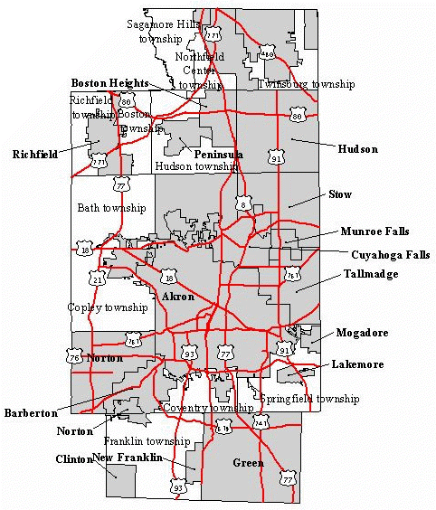
2.7 Summit County

Summit County’s Department of Environmental Services (DOES) operates and maintains the wastewater collection, transportation and distribution systems, and water distribution and purification chiefly in the unincorporated areas of the county and some incorporated areas. These areas compose the Summit County Metropolitan Sewer District. DOES includes separate Water and Sewer divisions, which its website says have different functions and sets of employees. According to DOES director David Marquard, however, states that the department has about 160 employees, and only a few are dedicated to water.

DOES prepares the sewer and water bills and collects the user fees and charges for deposit into the County treasury.

The Summit County Department of Planning made an inventory of infrastructure facilities such as wastewater treatment plants. They provided Microsoft Access database files with their locations, ready to be converted to GIS maps. The files are located on a zip file that is attached (Service_Areas).

Sewer

DOES operates 12 water treatment plants, about 800 sanitary sewer lines, and over 100 pumping stations. The sewer maintenance fee for property owners within is sewer district is .43/abutting front foot of property, with a minimum of $43 a year. It has about 42,000 customers, including those residents within incorporated areas that are serviced by DOES through municipal agreement.

The other major areas that operate their own sewer systems within the County are Akron (39 Combined Sewer Overflows, 30 pump stations, 638 miles of sanitary sewers, 180 combined sewers – see http://www.ci.akron.oh.us/CSO/Facts.htm, and http://www.ci.akron.oh.us/CSO/CSO.htm), Twinsburg, Barberton, Bath, and Cuyahoga Falls. Despite this, the municipalities routinely use each others’ equipment and water resources, and are billed for doing so. According to Marquard, there are about 180 agreements on sewage system usage and charges.

Water

DOES services only the city of Hudson and is working on selling off its water division. Other water distribution providers within the county are Akron (and surrounding areas such as Stow), Cleveland Water (northern areas including Twinsburg, Richfield, Boston Heights, Macedonia, and Northfield), and Cuyahoga Falls (which has 1 water plant and 18 drilling wells for supply), Bath and Barberton.

Sewer Rates
(Keep in mind 7500 gallons = 1000 cubic foot; Mgal = thousand gallons)

Summit County Metropolitan Sewer District Patrons (42,000):
Cost per 100 cubic feet: Residential/Governmental/Institutional - $4.41
Commercial - $4.99
Industrial – 5.79

Barberton (27,899 residents, 2000 Census):
Cost per Mgal/month: First 30 Mgal - $3.65
After - $2.93
(there are also minimum charges per month based on meter size)

Norton (11,523 residents supplied by City of Barberton):
Cost per Mgal/month First 30 Mgal - $5.47
After - $4.40

Cuyahoga Falls (49,374 residents):
Cost per 400 cubic feet/month: $3.146 (plus $2 service charge)

Akron (90,116 households, or 217,074 residents):
Average use: 6,000 gallons, or 800 cubic feet - $22.22/month per homeowner (average) – as of 2002

Twinsburg: (17,006 total residents – 59% urbanized – 10,033):
Per Household: $120/month
Commercial: $93.75/toilet or urinal, $46.88 per sink or drain, $50 per shower/floor drain (for calculation purposes, assume four toilets, 2 sinks, and one shower per business)
Industrial: $93.75 per year minimum, plus $23.44/person (assume 15)
(industrial waster-producing users pay additional fees)

Water Rates

Barberton (27,899 residents):
Cost per Mgal (thousand gallons): 1-30 Mgal usage - $3.21
31-120 Mgal usage - $2.86
Over 120 Mgal usage- $2.68
Cleveland Water
For Twinsburg (17, 066), Richfield (5,24), Boston Heights (1,186), Macedonia (9,224), Northfield (4,931):
Minimum cost per 3-month billing period: Within first 1000 cubic feet – $18.36
After - $20.93
Large industrial customers: In excess of 62.5 million cubic feet, rate is 75% of the “After” rate

Akron Water

Cuyahoga Falls (55,000 users):
Cubic feet per month: $1.528 (minimum 400 cubic feet)

Summit County Summary

For the most part, sewer and water service is local to the municipality. Most communities who choose not to use the county’s sewer services have their own, even though the lines are often other municipalities’, like Akron’s. Water distribution service, on the other hand, is shared from larger municipalities like Akron and Cleveland. Hence, scenarios 2 (Cooperation and Tinkering) and 3 (Service Mergers) are already taking place. If some municipal boundaries merged, this may not cause much of an interruption in service – a unified northern area could be unified under Cleveland water, the southern area under Akron water, Bath on the western side. David Marquard, the Summit County DOES director, indicated that in his opinion, sewer and water service should be regionalized to the county (Scenario 5), but that is unlikely to happen. He says that the communities seem to want to operate these systems on their own.

The numbers may be skewed considered the low number of users, but from an efficiency standpoint, the Summit County Department of Environmental Services spends $56.10 per resident served (not total residents) for water service, and $748.06 for every resident served (not total residents) for sewer service. This information is available in the DOES budget.

3.0 Other Metropolitan Water and Sewer Service Providers

The two metro areas that will be looked at closer are the Minneapolis-St. Paul area and the Washington, DC area. The Twin Cities region makes for a good comparison because the population of its metro area is similar to that of the Cleveland metro area. The Metropolitan Council is the governmental entity that coordinates over the seven county region. Sewer services in the Twin Cities area are provided by the Metropolitan Council Environmental Services (MCES). They own and operate all of the wastewater treatment plants, interceptors, and lift stations. No tax revenues support operation costs and cities are responsible for maintaining the sewer lines from homes and businesses to the MCES lines. The average annual cost for a residential user is about $180. Sewer service in Cuyahoga County costs over $300. The Metropolitan Council does not provide water service; however, they do coordinate water systems over the seven county area. The Metro Council has short term and long term plans addressing expected and existing water supplies. The council works with municipalities to solve water supply issues. Additionally, each city is required to submit a water supply plan along with their comprehensive plan. Water service for residential users in the Twin Cities Metro Area average $174 annually. This is comparable for the City of Cleveland, but suburban areas in Cleveland pay over $300 a year in water services. Sewer and water services in the Cleveland Metro Area could possibly save money and provide better service by moving towards a system like Minneapolis-St. Paul Metro.

Because of the metropolitan government structure in Minneapolis-St. Paul, their sewer and water service system may not be as applicable to Cleveland as some other service providers. Therefore, we will look at the DC Water and Sewer Authority (DCWASA). This entity’s funding is separate from the DC government and has a service area of 725 square miles. They provide retail water and wastewater services to DC and wholesale wastewater treatment to Montgomery and Prince George counties in Maryland and Fairfax and Loudon counties in Virginia. Annual residential water rates are about $220 and sewer rates are about $330 annually, both of which are lower than Cuyahoga County averages.

In no way am I suggesting that we simply take one of these examples and just transplant it into Northeast Ohio. What is important to take from this section is that other cities and metro areas are doing it just as well if not better, and cheaper. This region needs to learn from these examples and other examples, using different aspects of each to improve service and lower costs.

4.0 Findings and Conclusions

We’ve discussed the basics of water distribution and waste water treatment and provided you with a basic knowledge of the workings of these systems within Cleveland’s seven county region.

Throughout the data collection process we searched for a way to measure system efficiently and customer value. In order to do this, two variables will be analyzed including customers served by a given system system, and average cost to the customer. This analysis holds all other factors constant. There are several things to consider regarding these factors not figured into the evaluation: population density has a large effect on a system including use and service; the distance from a water source can increase the cost to provide water; the same principal applies for waste water treatment in relation to topography; there are many other factors that may affect cost for users of a system.

The following tables and graphs show the relation between customer cost and system size:

Sewer Rate Comparison
Entity | Users | Monthly Rate (1.0 MCF)
Streetsboro | 12,327 | 20.36
Lake County | 37,200 | 21.76
Portage County | 25,641 | 23.44
NEORSD - Cleveland | 132,541 | 26.20
Medina | 38,000 | 26.25
Barberton | 28,000 | 27.30
NEORSD - Suburbs | 192,752 | 30.95
Euclid | 23,000 | 34.51
Summit County | 42,000 | 44.10
Lodi | 1,250 | 45.00

Water Rate Comparison
Entity | Users | Monthly Rate (1.0 MCF)
Cleveland Water | 132,713 | 8.13
Cleveland Water (1) | 185,195 | 14.48
Cleveland Water (2) | 149,832 | 16.72
Cleveland Water (3) | 80,295 | 19.60
Lake County | 39,000 | 21.77
Rural Lorain County | 19,000 | 28.20
Medina | 10,000 | 29.17
Akron/Cuy Falls | 22,000 | 29.55
Portage County | 11,000 | 36.22

Regression analysis was performed for both the water and sewer data collected. As you can see, although containing a weak R² value, the analysis performed for sanitary sewer providers shows that at some point around 110,000 customers an economy of scale may be reached. What does this mean? Should we regionalize and consolidate into sewer groups with customer bases of approximately 110,000 users? This scenario would create approximately 11 separate sewer districts. The effect of the variables not considered in the analysis is probably what is having us reach the conclusion with the data analyzed. The fact remains that although cost may increase on the margin, further consolidation of sewer services may have more positive effects than can be seen by this simple example.

The analysis for the water system showed us a more expected result of supply and demand. The larger the system, the less costly the water was for the customer, on the average. This is a good argument for the combination of all water services.

Five scenarios were considered when analyzing the regionalization of Northeast Ohio’s water and sewer systems. These scenarios range from One – Do nothing, to Five – Complete Consolidation of services. Through our analysis of the water systems in the seven county region we found examples of everything from local municipalities operating their own facilities to counties controlling the majority of their county’s sanitary services, to the North East Ohio Regional Sewer District. We found that some counties, and the NEORSD are already operating in the third scenario – Service Mergers.

Due to the fact that there may be economies of scale for sewer systems providers, and continued lower rates with the increase in size of water system providers, a combination of the two entities would prove to be the most efficient, thus closing the gap of increasing cost of sewerage for larger populations served. A complete merger of all water and sewer services in the seven county region would fall between the third scenario and the fifth – Regional Government – One Entity. It can be said that in terms of water and sewer, many counties may already be approaching a regional governance structure within their respective county, and reaping the efficiency awards. One can use Medina County for this example. They provide both water and sewer services to the majority of the county (of those who have service) and do so at competitive rates.

Regionalism provides an opportunity for water and sewer services to be consolidated, if not for efficiency, than for simplification. Even though Northeast Ohio hasn’t regionalized, much can be learned from the water and sewer systems in Northeast Ohio and how many have naturally regionalized on their own.

