Lake County Solid Waste District

- The Lake County Solid Waste District (the District) was established in 1990 in compliance with Ohio's solid waste law, HB 592. The District includes all 23 individual Lake County communities and is governed by its 7-member Policy Committee. The function of the Policy Committee is to develop strategies for waste management, to take the lead on 3-year County Solid Waste Management Plan updates, and to plan and oversee the special collection events.

- The federal mandate requires that local governments bear all costs associated with the new regulations, so Lake County instituted a stormwater user fee program. The fees are charged on individual parcels of land based on the amount of impervious area on the property (hard surface). The amount of impervious land is used because it has been shown to be a good indicator of the amount of runoff that leads to pollution. All residential properties are charged a base rate. Nonresidential properties are charged based upon the square footage they contain divided by the equivalent residential unit (ERU) which is 3,050 sq. ft. For example, a commercial property with 30,500 sq. ft. of impervious surface would pay 10 times that of a residential property (30,500/3,050=10).

To whom it may concern:

I am investigating the possibility of regionalizing storm water management throughout Northeast Ohio. It is our hypothesis that a regional storm water agency would be: (1) a more efficient way to allocate resources i.e. labor, machinery, and other pertinent equipment (2) a way to improve the effectiveness of all of Northeast Ohio’s storm water treatment facilities; and (3) a means to leverage more funds in hope to gain more Federal aid. I am looking for the following information:

- How would you envisioning joining forces with other municipalities or districts?
- What is the median age of the pipes/improvements or a range? Old? New?
- What is your budget and what are your rates?
- How many miles of pipe are you responsible for? What maintenance procedures do you have?
- Is there any equipment in your fleet that you need to own but do not need to use all that much?
- How many users are in your district?

If you could take a couple minutes and either answer the questions or provided sources where I could locate the following information would be of great help. I appreciate your effort

Department of Utilities:
Miles of sewer lines operated 817
Miles of water lines 563
Wastewater treatment plants operated 3
Wastewater pump stations operated 40
Water plants operated 2
Water booster stations operated 7
Water utility customers 39,256
Sewer utility customers 36,827

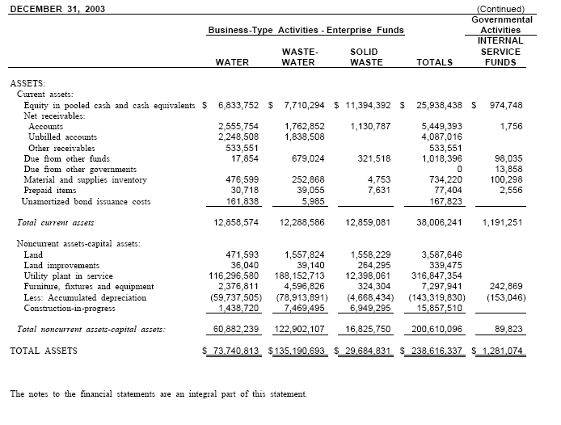

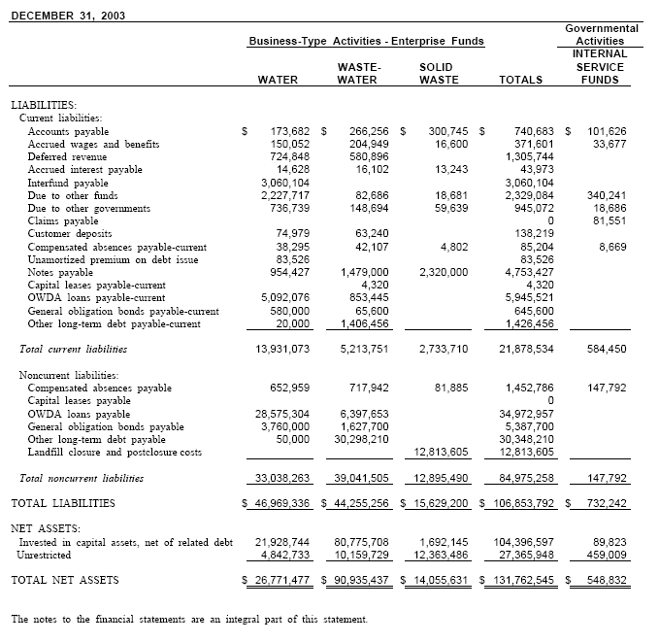

LIABILITIES:
Current liabilities:
Accounts payable 173,682 $ 266,256 $ 300,745 $ 740,683 $ 101,626
Accrued wages and benefits 150,052 204,949 16,600 371,601 33,677
Deferred revenue 724,848 580,896 1,305,744
Accrued interest payable 14,628 16,102 13,243 43,973
Interfund payable 3,060,104 3,060,104
Due to other funds 2,227,717 82,686 18,681 2,329,084 340,241
Due to other governments 736,739 148,694 59,639 945,072 18,686
Claims payable 0 81,551
Customer deposits 74,979 63,240 138,219
Compensated absences payable-current 38,295 42,107 4,802 85,204 8,669
Unamortized premium on debt issue 83,526 83,526
Notes payable 954,427 1,479,000 2,320,000 4,753,427
Capital leases payable-current 4,320 4,320
OWDA loans payable-current 5,092,076 853,445 5,945,521
General obligation bonds payable-current 580,000 65,600 645,600
Other long-term debt payable-current 20,000 1,406,456 1,426,456
Total current liabilities 13,931,073 5,213,751 2,733,710 21,878,534 584,450

LIABILITIES:
Current liabilities:
Accounts payable
Accrued wages and benefits
Deferred revenue
Accrued interest payable
Interfund payable
Due to other funds
Due to other governments
Claims payable
Customer deposits
Compensated absences payable-current
Unamortized premium on debt issue
Notes payable
Capital leases payable-current
OWDA loans payable-current
General obligation bonds payable-current
Other long-term debt payable-current
Total current liabilities

